Inosivut 2222
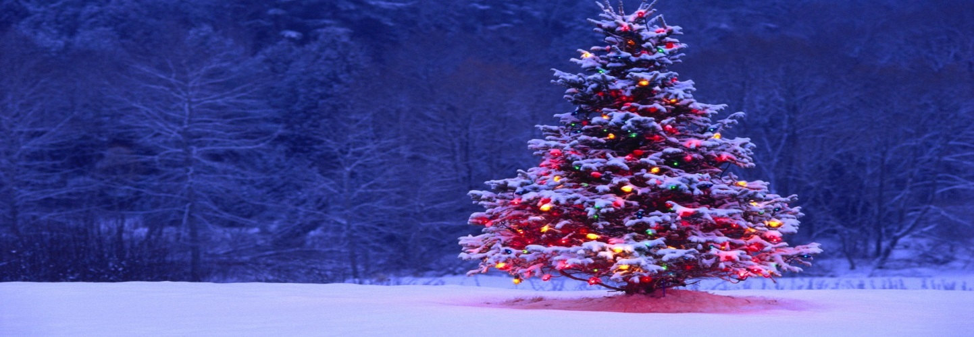
Our Christmas Traditions
Name: ______________________
Labrador is an area rich in traditions. Times when family gets together and celebrates with their community. Describe some of the traditions that you know of that take place during the holiday season. These can be personal from your family, or ones that you know happen for the whole community. If you don’t know of many then research them online or by using the stories in the Them Days Magazines. DO NOT simply list the events, describe them in detail.

