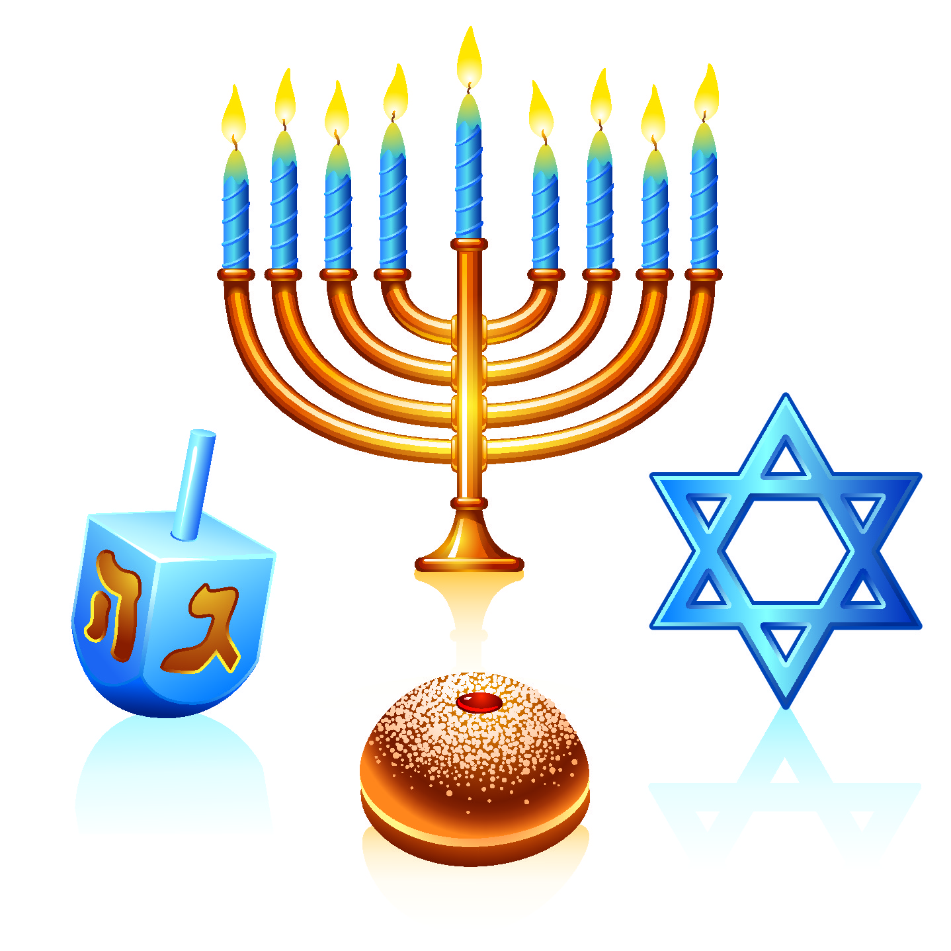
Hanukkah
Name: ________________________________ Date: ______________
Research the origins and traditions that surround the celebration of Hanukkah. Then answer the following questions.

- What religious group celebrates Hanukkah?
Jews

- When does Hanukkah happen, and why is it at that time of the year?

It lasts for 8 days starting on the 25th day of Kislev, which usually falls in November or December. This year Hannukkah begins

- What is the meaning of the word Hanukkah, or is there an English name given to this celebration?

Hannukkah means dedication. It celebrates the rededication of the temple in Jerusalem after the desecration caused by the Greek/Egyptian occupiers during the 2th century BC. It is also called the Festival of Lights

- What historical event is remembered in the Hanukkah celebration? Give the background information for this event.
Around 200 B.C., Judea—also known as the Land of Israel—came under the control of Antiochus III, the Seleucid king of Syria, who allowed the Jews who lived there to continue practicing their religion. His son, Antiochus IV Epiphanes, proved less benevolent: Ancient sources recount that he outlawed the Jewish religion and ordered the Jews to worship Greek gods. In 168 B.C., his soldiers descended upon Jerusalem, massacring thousands of people and desecrating the city’s holy Second Temple by erecting an altar to Zeus and sacrificing pigs within its sacred walls.
Led by the Jewish priest Mattathias and his five sons, a large-scale rebellion broke out against Antiochus and the Seleucid monarchy. When Matthathias died in 166 B.C., his son Judah, known as Judah Maccabee (“the Hammer”), took the helm; within two years the Jews had successfully driven the Syrians out of Jerusalem, relying largely on guerilla warfare tactics. Judah called on his followers to cleanse the Second Temple, rebuild its altar and light its menorah—the gold candelabrum whose seven branches represented knowledge and creation and were meant to be kept burning every night.
According to the Talmud, one of Judaism’s most central texts, Judah Maccabee and the other Jews who took part in the rededication of the Second Temple witnessed what they believed to be a miracle. Even though there was only enough untainted olive oil to keep the menorah’s candles burning for a single day, the flames continued flickering for eight nights, leaving them time to find a fresh supply. This wondrous event inspired the Jewish sages to proclaim a yearly eight-day festival.

- What does the Menorah represent during Hanukkah? How do they use it during the Hanukkah week?

The Hanukkah celebration revolves around the kindling of a nine-branched menorah, known in Hebrew as the hanukiah. On each of the holiday’s eight nights, another candle is added to the menorah after sundown; the ninth candle, called the shamash (“helper”), is used to light the others. Jews typically recite blessings during this ritual and display the menorah prominently in a window as a reminder to others of the miracle that inspired the holiday.

- What special traditions are done for the Hanukkah celebrations? Is there a meaning behind each of these traditions? (you can start with any of the objects from the image at the top of the page)

In another allusion to the Hanukkah miracle, traditional Hanukkah foods are fried in oil. Potato pancakes (known as latkes) and jam-filled donuts (sufganiyot) are particularly popular in many Jewish households. Other Hanukkah customs include playing with four-sided spinning tops called dreidels and exchanging gifts. In recent decades, particularly in North America, Hanukkah has exploded into a major commercial phenomenon, largely because it falls near or overlaps with Christmas. From a religious perspective, however, it remains a relatively minor holiday that places no restrictions on working, attending school or other activities

