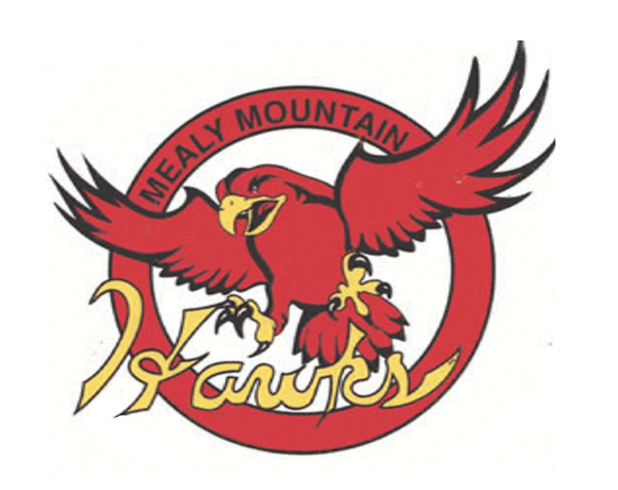

**Math 2202**

**Supplemental Final Exam**

**Student: ___________________________________**

**Teacher: Mr. Gillett**

**General Instructions**

1. Students are required to do ALL items**.**

2. The examinationconsists of the following parts:

Section A**:** 30 Selected Response *Value: 50%*

*Use the answer sheet provided to record all responses*

Section B: 8 Constructed Response V*alue: 50%*

*Complete all questions in the space provided, showing all workings for complete marks.*

**DO NOT OPEN THIS EXAMINATION PAPER UNTIL YOU ARE TOLD BY THE SUPERVISOR TO BEGIN**

**Formulas**

**Rectangle**

Area = l x w

Perimeter = 2l + 2w

**Circle**

$$A=πr^{2}$$

$$Circumference=2πr$$

**Triangle**

$$A=\left(\frac{b x h}{2}\right)$$

**Cube**

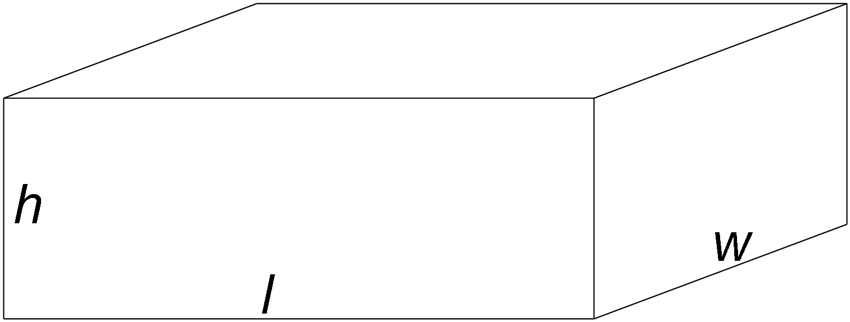

**Rectangular prism**

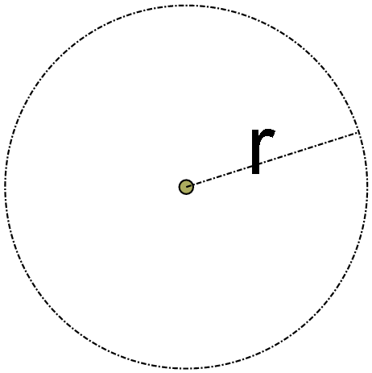 $V=l x w x h$



$SA=2\left(lxw\right)+2\left(lxh\right)+2(wxh)$ 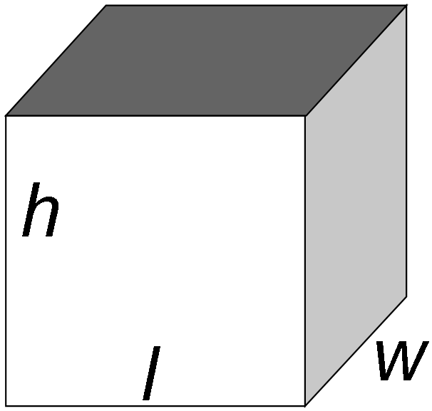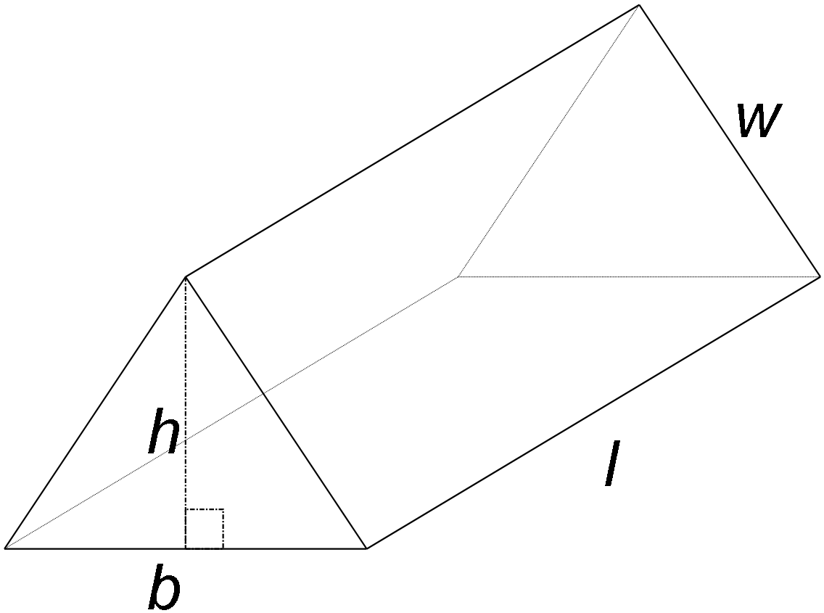

**Triangular Prism**

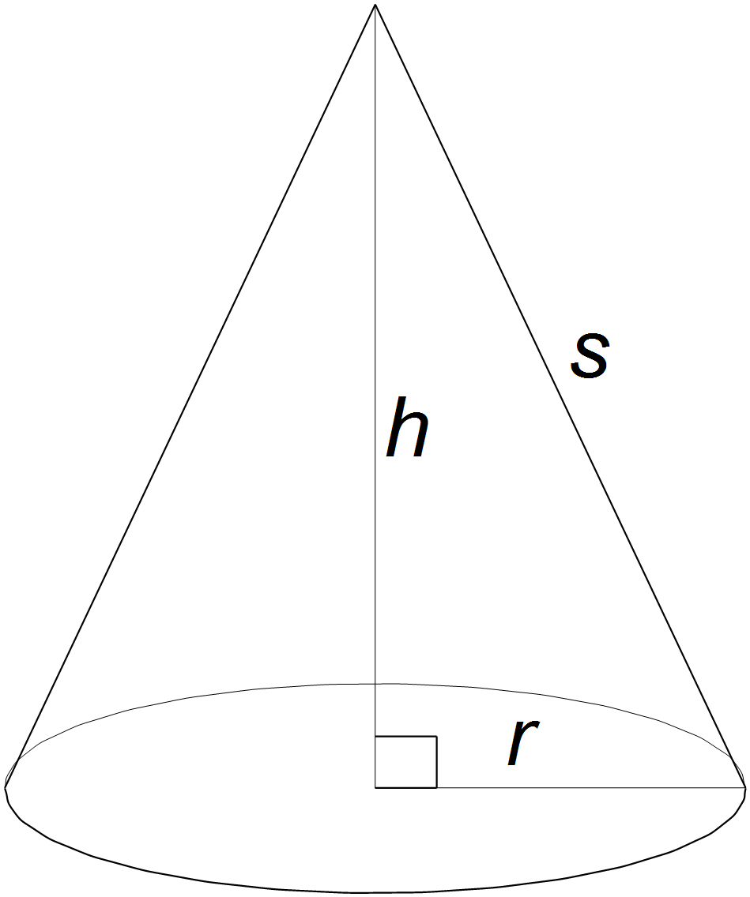

**Cylinder Cone**

$SA=2πr^{2}+ 2πrh$ $SA=πr^{2}+πrs$

$V=πr^{2}h$ $V=\frac{πr^{2}h}{3}$

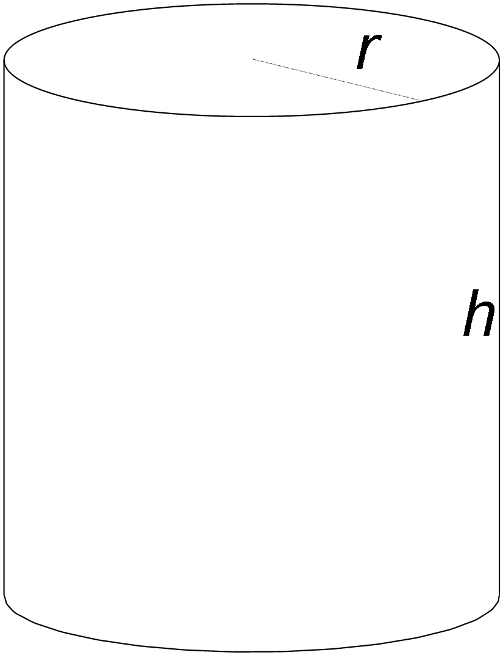

**Sphere**

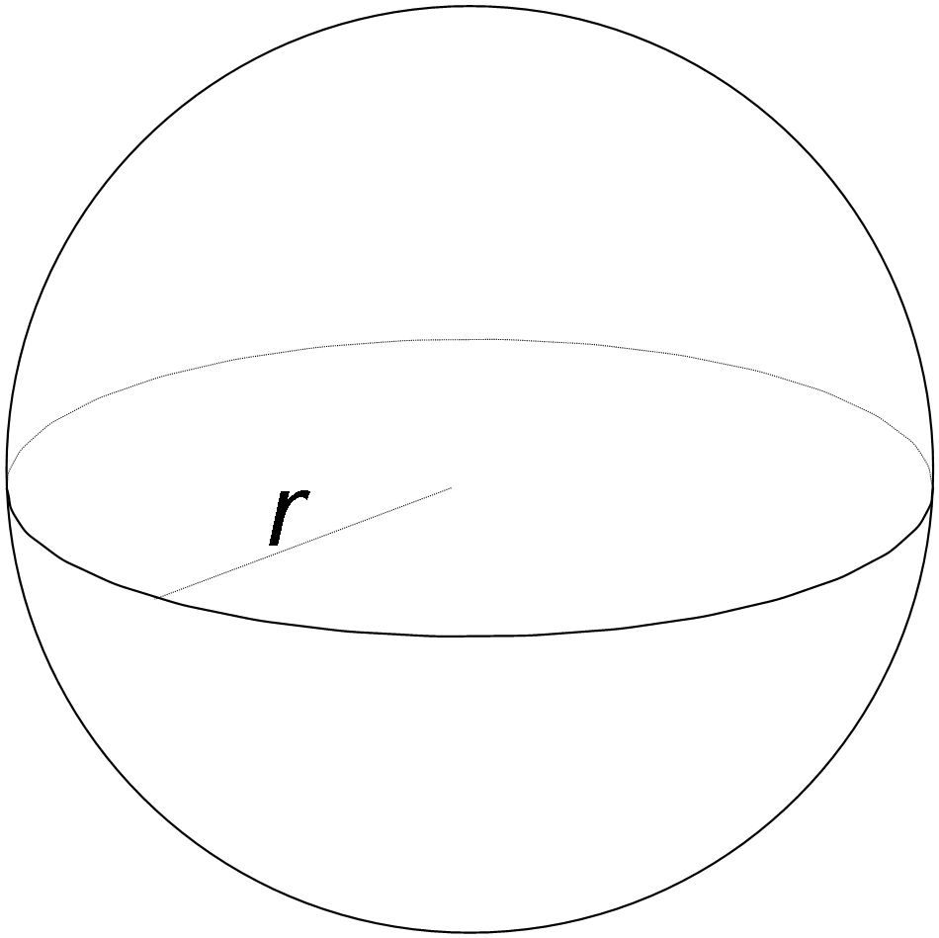

**Simple Interest Compound Interest**

$I=p r t$ $TotalValue={P(1+ \frac{r}{n})}^{tn}$

$$FutureValue=P+I$$

**Trigonometry**

$\tan{θ}=\frac{opposite}{adjacent}$ $\sin{θ}{=\frac{opposite}{hypotenuse}}$ $\cos{θ=\frac{adjacent}{hypotenuse}}$

**Math 2202 Final Exam**

Response Sheet

( Put you name on this sheet and you may remove it from your test)

Student Name: ____________________

Circle the letter of the best response for each question.

1. A B C D
2. A B C D
3. A B C D
4. A B C D
5. A B C D
6. A B C D
7. A B C D
8. A B C D
9. A B C D
10. A B C D
11. A B C D
12. A B C D
13. A B C D
14. A B C D
15. A B C D
16. A B C D
17. A B C D
18. A B C D
19. A B C D
20. A B C D
21. A B C D
22. A B C D
23. A B C D
24. A B C D
25. A B C D
26. A B C D
27. A B C D
28. A B C D
29. A B C D
30. A B C D

**Section A - Selected Response (50%)**

***Chapter 1***

1. Which 3-D object can be made from this net?

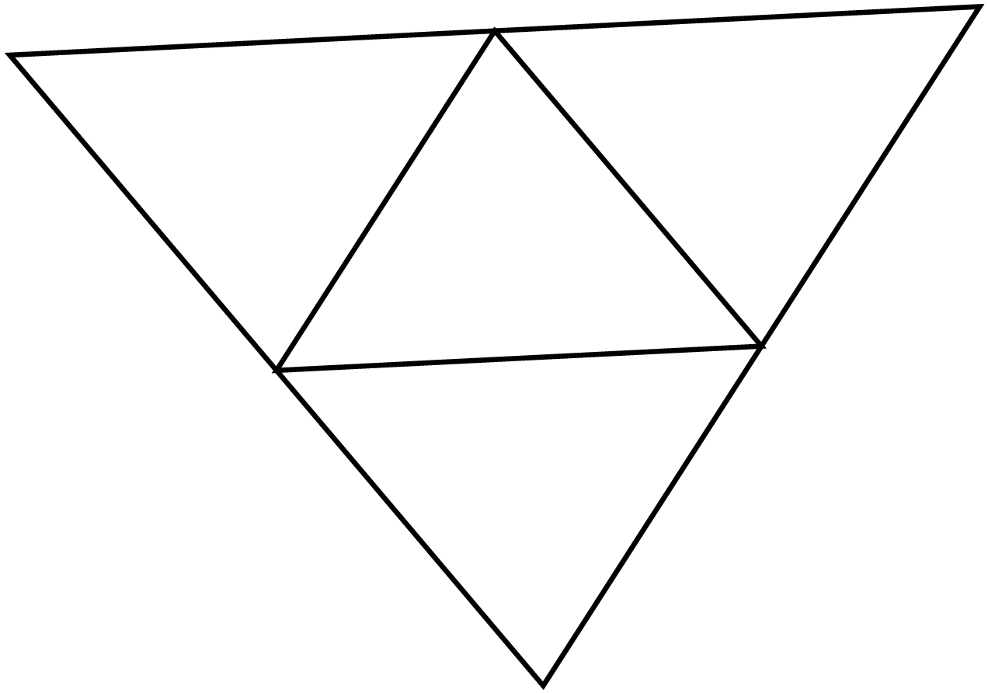

1. Rectangular prism

B) Rectangular pyramid

C) Triangular prism

D) Triangular pyramid

2. What is the total surface area of the right triangular prism using its net?

A) 360 in2

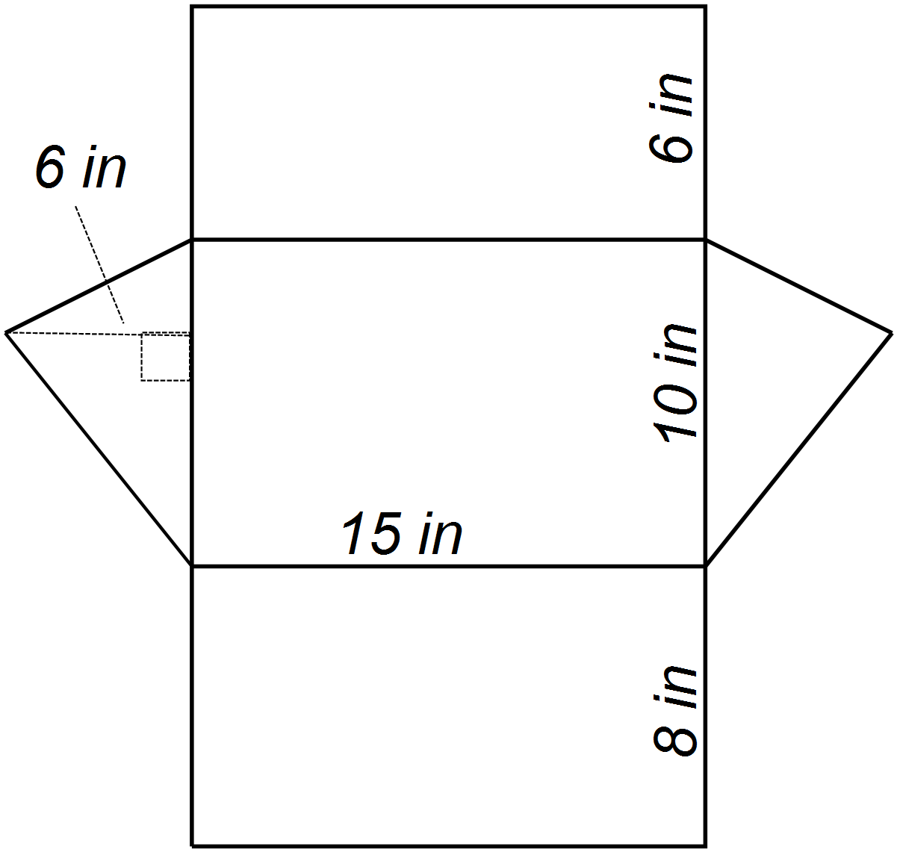

B) 420 in2

C) 480 in2

D) 504 in2

3. What is the total surface area of the rectangular prism?

|  |  |
| --- | --- |
|  |  |

1. 44 cm2

B) 144 cm2

C) 288 cm2

D) 576 cm2

1. A cylindrical tank is 6 ft tall. The radius of the base is 2 ft. Which value is the best estimate for the surface area of the cylinder?

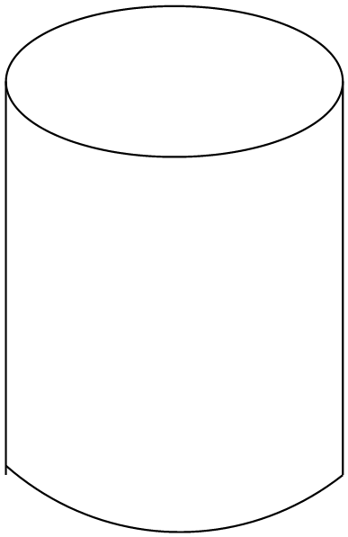

1. 44 ft2

B) 101 ft2

C) 170 ft2

D) 251 ft2

|  |  |
| --- | --- |
|  |  |

1. What is the total surface area of the sphere shown?

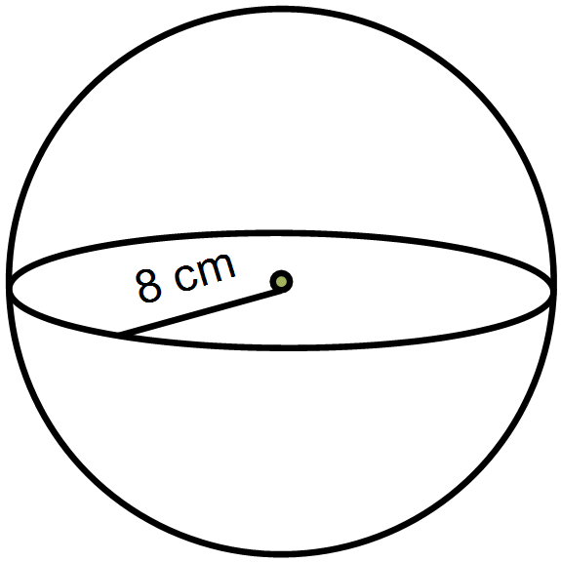

1. 50 cm2
2. 101 cm2

1. 201 cm2
2. 804 cm2

***Chapter 2***

6. You want to landscape your backyard which is 12 m wide and 20 m long. If you make a planning diagram with a scale of 1:100, what will be the dimensions of your scale drawing?

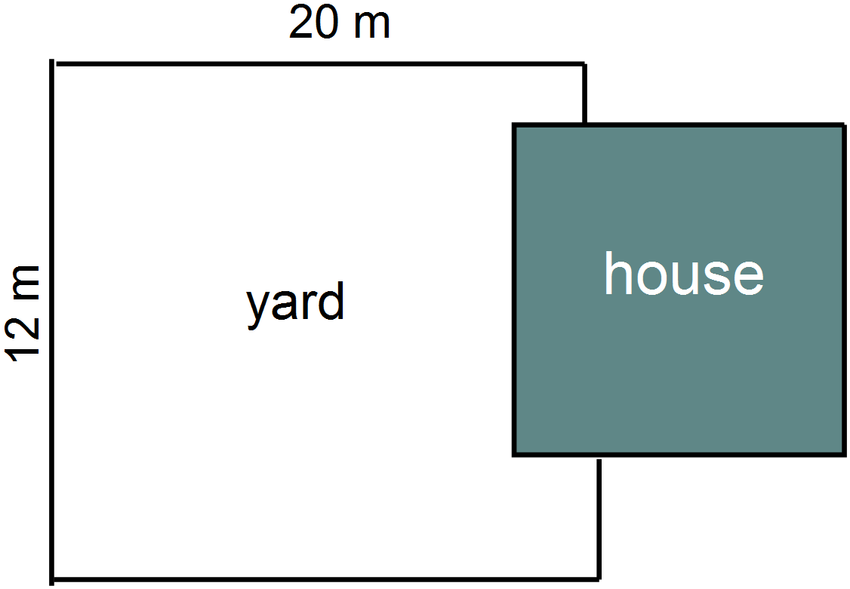

1. 6 cm by 10 cm

B) 12 cm by 20 cm

C) 18 cm by 30 cm

1. 24cm by 40 cm
2. 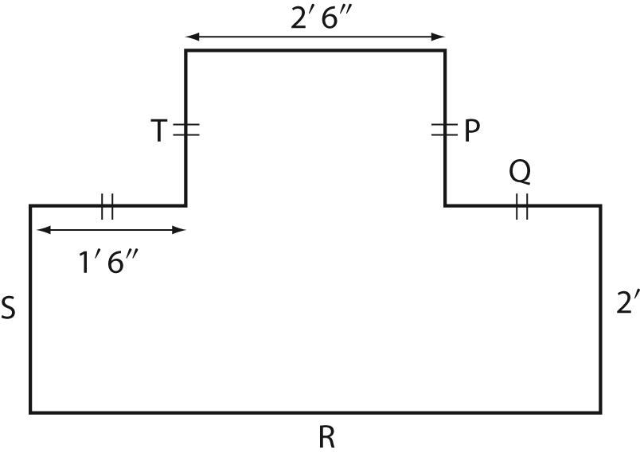What is the length of the side ‘R’ ?
   1. 2’ 6”
   2. 3’ 6”
   3. 5’ 0”
   4. 5’ 6”
3. 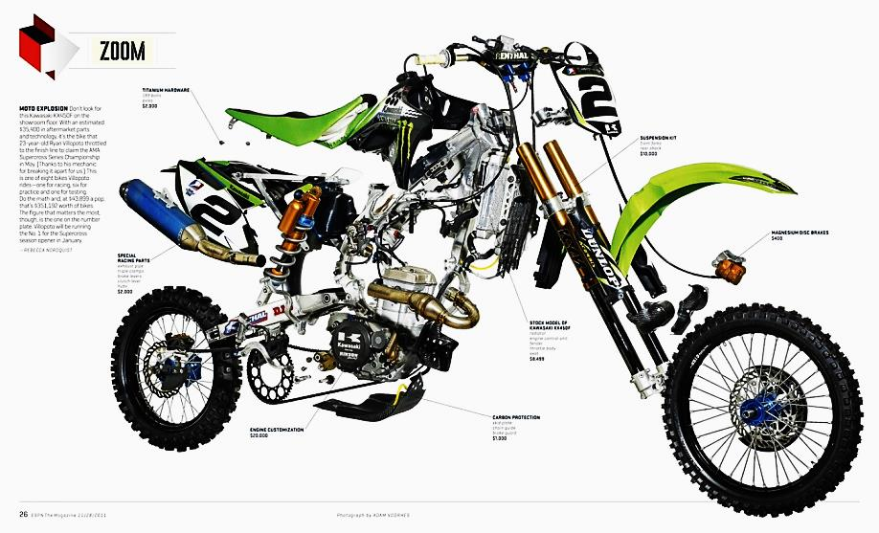Here are some base diagrams of a motorbike. What type of drawing is this?
   1. Exploded view
   2. Isometric
   3. One-point perspective
   4. Orthographic
4. 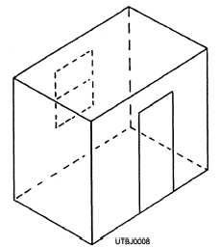What type of drawing method was used to create this diagram of a room?
   1. Exploded view diagram
   2. Isometric drawing
   3. One-point perspective drawing
   4. Orthographic drawing
5. 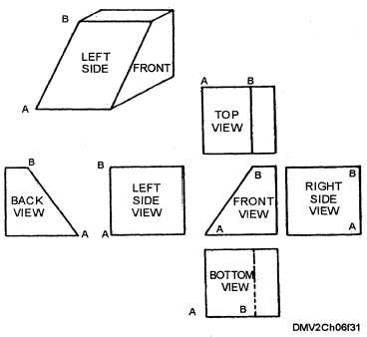 What type of drawings are shown here to model a new skateboard ramp?
   1. Exploded view diagram
   2. Isometric drawing
   3. One-point perspective drawing
   4. Orthographic drawing

***Chapter 3***

1. What is the volume of the sphere shown?

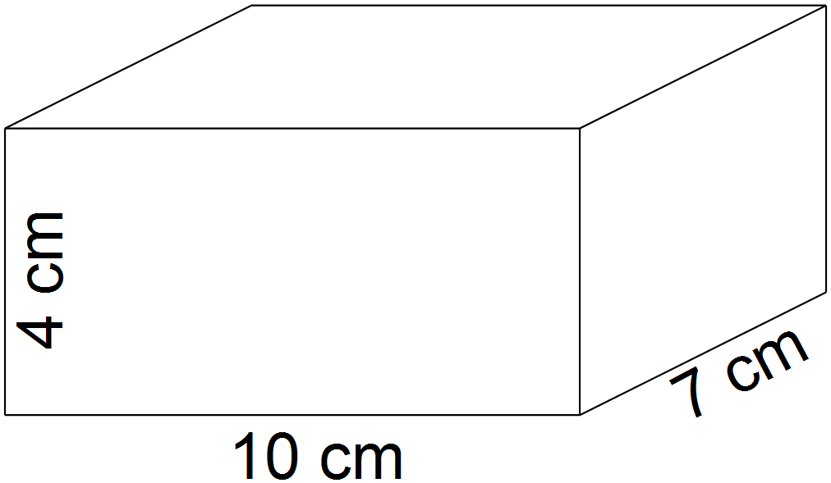

1. 80 cm3
2. 140 cm3

1. 276 cm3

D) 280 cm3

1. Which volume is closest to that of a large glass of water?

A) 1 cup

1. 1 gallon
2. 1 litre
3. 1 pint

13. What is the approximate total volume of the cylinder shown?

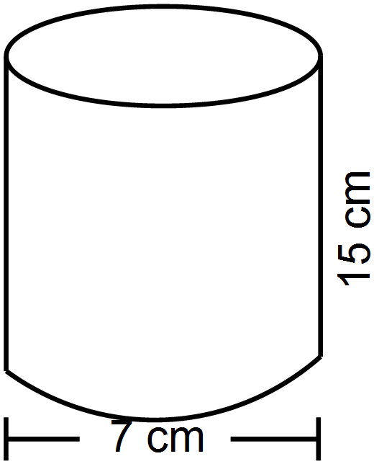

A) 160 cm3

B) 215 cm3

C) 290 cm3

D) 575 cm3

14. A hollow basketball has a radius of 8 inches. What is the total air capacity of the ball if it is fully inflated?

A) 268 in3

B) 804 in3

C) 2145 in3

1. 6434 in3

15. This winter the town plans to build a snow jump at Johnny Hill. What is the total volume of snow needed to build this jump?

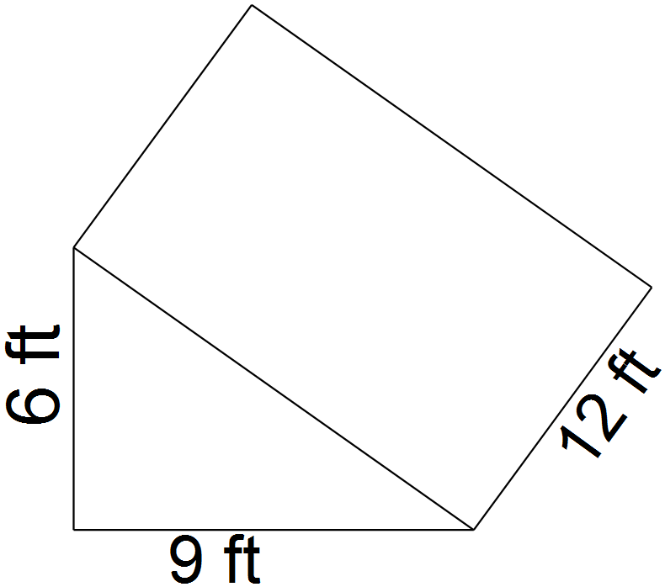

A) 162 ft3

B) 324 ft3

C) 648 ft3

D) 810 ft3

16. How many pints of ice cream are in 2 gallons?

1. 2
2. 4
3. 6
4. 8

***Chapter 4***

1. Which graph would best show the population growth of Happy Valley – Goose Bay over the last 10 years?
   1. A Bar Graph
   2. A Circle Graph
   3. A Line Graph
   4. A Scatterplot
2. The Graduating class voted on which colours they wanted for their prom. What type of graph would best show the different colours the students chose?
   1. A Bar Graph
   2. A Circle Graph
   3. A Line Graph
   4. A Scatterplot
3. What is the word used to describe the total number of people in each group?
   1. Census
   2. Frequency
   3. Quantity
   4. Totality
4. A number of students were asked which was their favorite team for winning the Stanley Cup from the teams in the last round. 36 students said Boston, 22 said the Kings, 85 said Montreal, 15 said Chicago and 30 said they had no favorite from the remaining teams. How many students made up the total population of the survey?
   1. 136
   2. 158
   3. 188
   4. 218
5. Which bar graph would you use to best **misrepresent** the data to favour the Hawk team?
   1. The width of the bar is wider for the Hawks team than the Gulls
   2. The vertical axis starts at 0 and ends at the Hawks average height
   3. The vertical axis starts at 6 foot 3 inches and increases by ¼ inch increments.
   4. The width of the bars are the same for the Hawks and the Gulls

***Chapter 5***

1. A bank charges $4.50 per month for managing an account. The account fee allows 6 transactions each month. Additional transactions are $1.00 each. How much would you pay for service charges if you had 16 transactions this month?
   1. $4.50
   2. $14.50
   3. $16.00
   4. $20.50
2. Sam estimates that he uses his debit card at least twice a day. What type of account should he have?
   1. Chequing Account
   2. Credit Account
   3. Savings Account
   4. Transverse Account
3. Which of the following is NOT a fixed expense?
   1. Car Repair Bill
   2. Car Payment
   3. Cell Phone Bill
   4. Rent

25. What would be the total future value of an investment of $2000, invested at 3% for 2 years with simple interest?

1. $ 60
2. $ 2060
3. $ 2120
4. $ 2600

26. What would be the value of an investment of $4000 compounding annually at 5% over 10 years, rounded to the nearest dollar?

A) $ 4050

1. $ 6515
2. $ 6617
3. $ 6758

***Chapter 7***

27. Which of the following is the value of ?

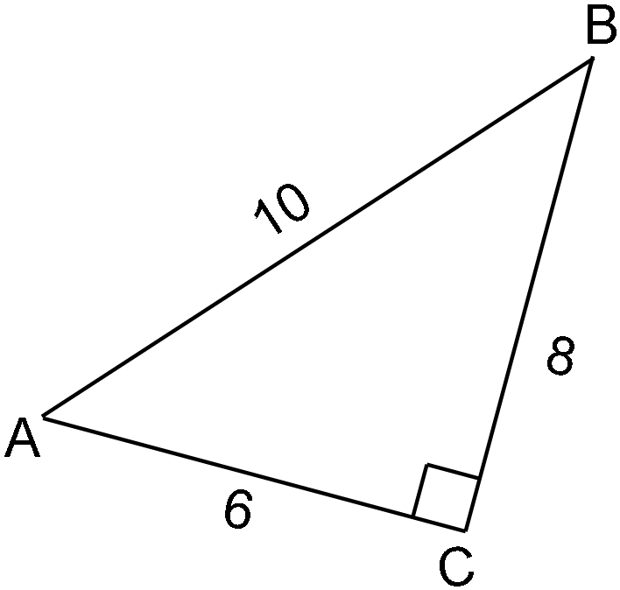

28. Which is the correct Trigonometry Ratio that can be used to find the size of angle X ?









29. Which is the correct Trigonometry Ratio that can be used to find the height of the tree ?

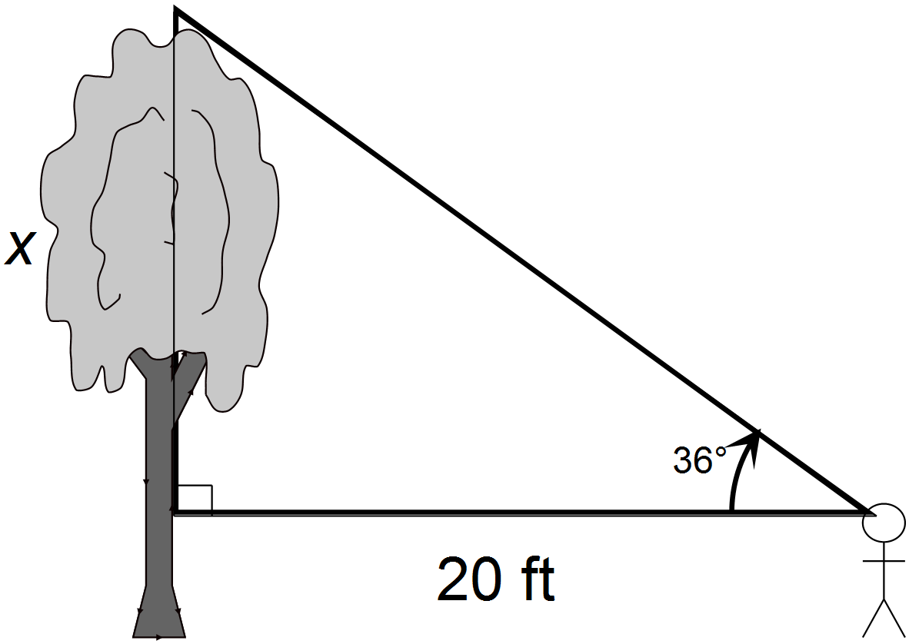







30. How long is a ladder whose base is 3 feet from a wall and makes an angle of 80o with the ground?

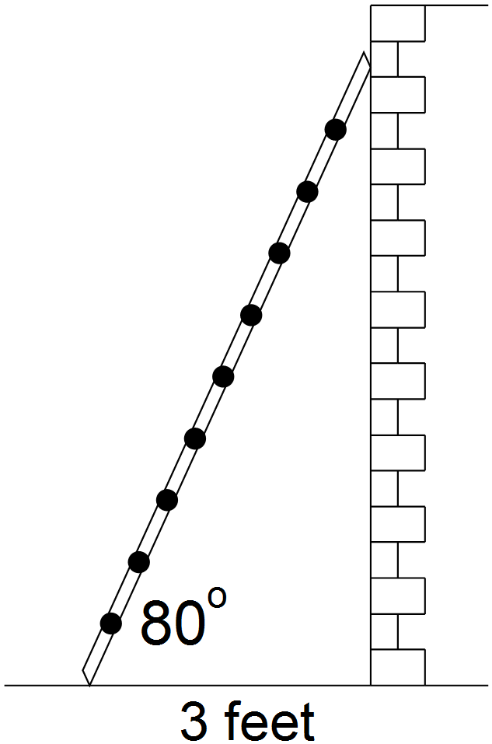

A) 10 ft

1. 12 ft
2. 14 ft
3. 17 ft

**Part II – Constructed Response:**

Answer each of the following in the space provided. Show all workings to ensure full marks.

***Chapter 1***

31. Consider the following triangular prism:

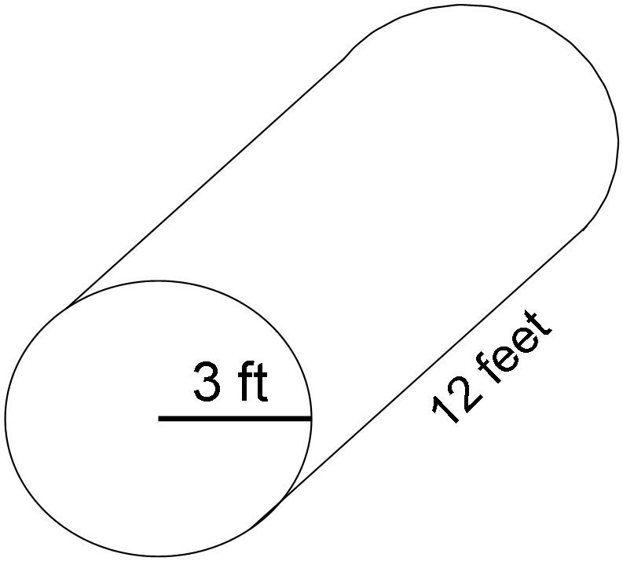

A) Use a ruler and **Sketch a net** of the cylinder (1 mark)

1. Calculate the total **surface area** of the cylinder. (2 marks)

***Chapter 3***

32. The new Mother Woods dug a ramp shaped trench leading to the delivery door of their warehouse. Calculate the **volume** of dirt that was removed to build the trench. (2 marks)

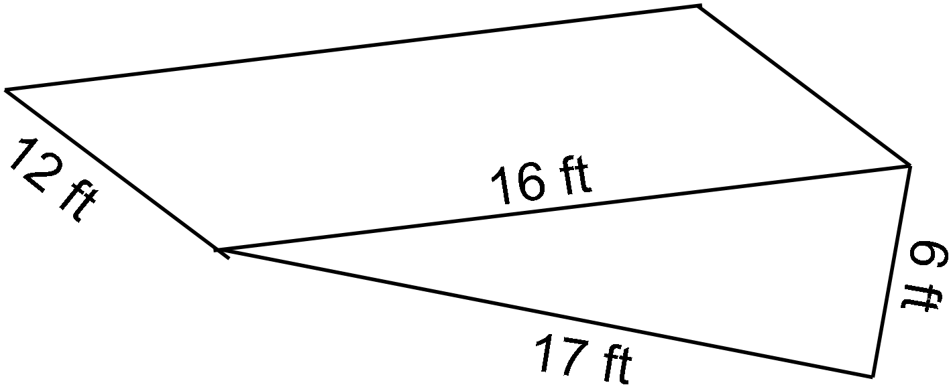

***Chapter 4***

1. Sarah’s mom has recorded her height from the time she was born. The data is recorded in the chart shown.

|  |  |
| --- | --- |
| Age (years) | Height (in.) |
| 0 | 22 |
| 1 | 28 |
| 2 | 30 |
| 3 | 33 |
| 4 | 37 |
| 5 | 40 |
| 6 | 41 |
| 7 | 43 |

* 1. Which type of graph would be most effective to show Sarah’s growth during these years? Explain why you think this is the best type of graph. (1 mark)
  2. Draw the graph that you chose in part A to represent the data given. Clearly mark the scales and give the graph an appropriate title. (3 marks)

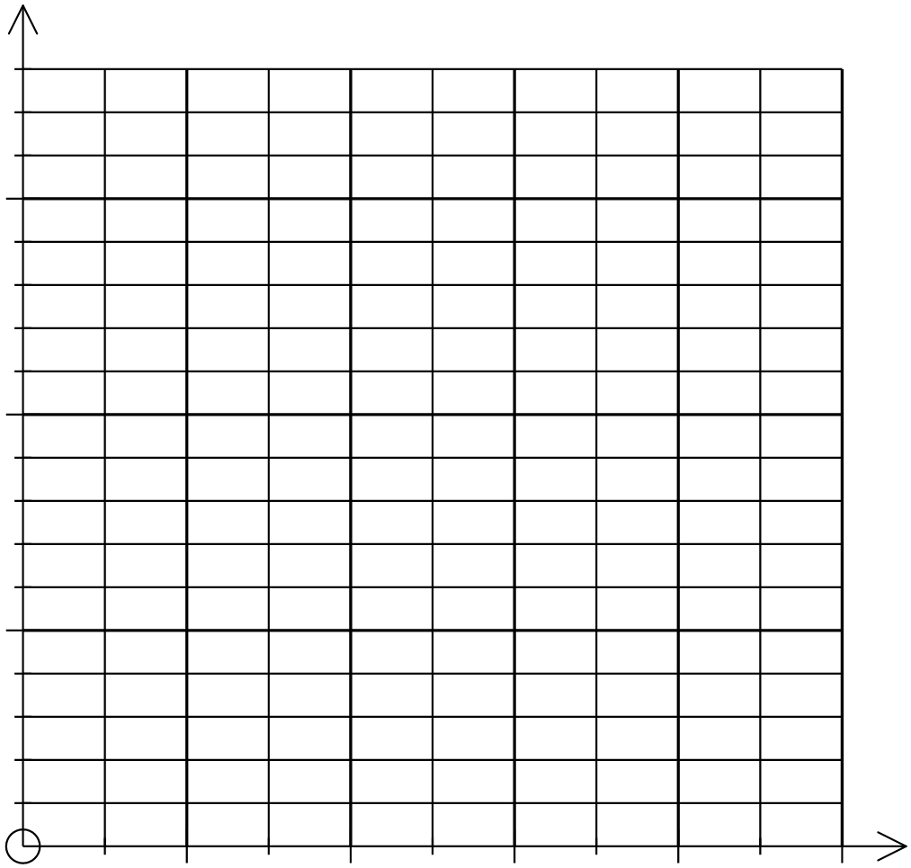

***Chapter 5***

1. The chart below shows the May budget record for Tim and Mary.

|  |  |
| --- | --- |
| May Budget | |
| Income ($) | |
| Tim | 1650 |
| Mary | 1600 |
| **Total Income** | **3250** |
| Expenses ($) | |
| Rent | 800 |
| Groceries | 550 |
| Gas | 200 |
| Entertainment | 100 |
| Phone/cable/Internet | 150 |
| Cell phone | 50 |
| Gym | 90 |
| Car insurance | 200 |
| Saving to buy a condo | 400 |
| Gifts and charity | 200 |
| Restaurants | 200 |
| Education fund | 300 |
| For a “rainy day” | 10 |
| **Total Expenses** | **3050** |
| **Income – Expenses** | **200** |

1. What are Tim and Mary’s likely Fixed Expenses in the month? (2 marks)
2. Is their budget balanced? Explain why or why not. (1 marks)
3. They have a goal to go on a vacation next year and need to save money. What would you change in the monthly budget that could help them save $300 per month for their vacation plan? (2 marks)

***Chapter 2***

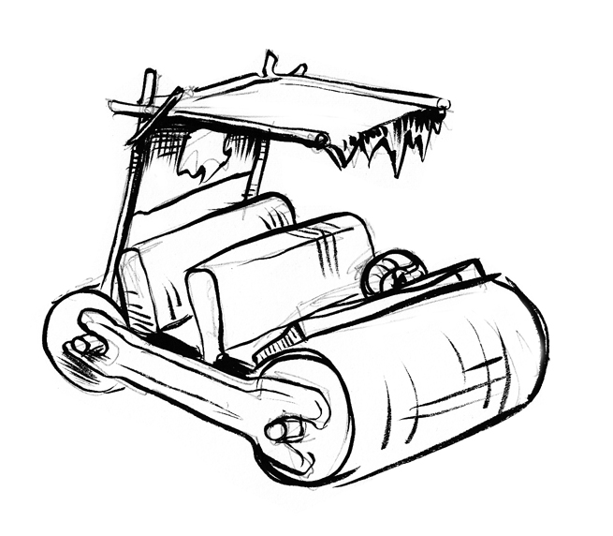35. Create a full set of Orthographic drawings, showing front, back, side and top views of the vehicle shown. (4 marks)

1. Calculate the final future value of each of the following investments.
   1. A $900 investment collects simple interest for 5 years with 4%. (2 marks)
   2. A 4-year investment of $10 000 at 7% compounded monthly. (2 marks)

***Chapter 7***

1. Solve for the missing side or angle in each triangle using Trigonometry (4 marks)

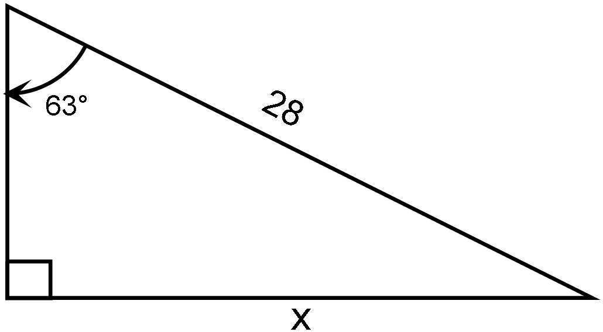



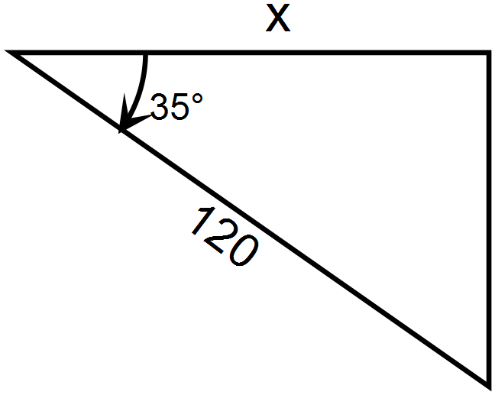

1. A conveyor belt is being used to move shingles up to a rooftop. The house is 8 meters tall. The base of the conveyor belt is 15 meters from the base of the house.

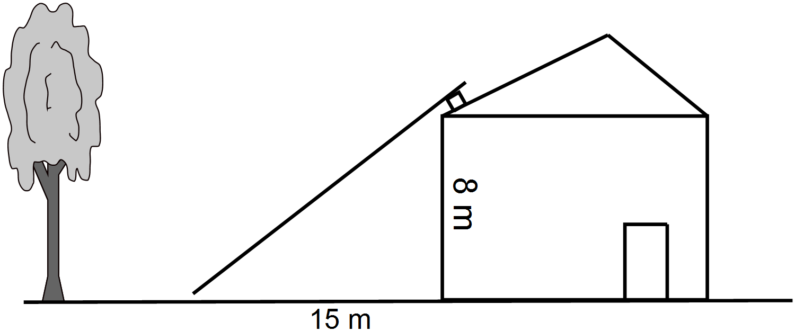

* 1. Use Trigonometry to find the angle of elevation needed to make the conveyor reach the roof of the house. (2 marks)
  2. Using Trigonometry, how long should the conveyor belt be in order to reach the roof safely, round to the nearest meter. (2 marks)