

**Mealy Mountain Collegiate**

**Canadian History Final Exam**

**June 2014**

Student: ________________________

**Instructions**

**Part 1: 50 Selected Response Items 50%**

**P**ut the letter of the correct response on the answer sheet provided.

**Part 2. 4 Constructed Response Items 50%**

**A**nswer all questions in the spaces provided on the exam.

**Canadian History Final Exam**

Response Sheet

* Put you name on this sheet and you may remove it from your test
* Circle the letter of the best response for each question.

Student Name: ____________________

1. A B C D
2. A B C D
3. A B C D
4. A B C D
5. A B C D
6. A B C D
7. A B C D
8. A B C D
9. A B C D
10. A B C D
11. A B C D
12. A B C D
13. A B C D
14. A B C D
15. A B C D
16. A B C D
17. A B C D
18. A B C D
19. A B C D
20. A B C D
21. A B C D
22. A B C D
23. A B C D
24. A B C D
25. A B C D
26. A B C D
27. A B C D
28. A B C D
29. A B C D
30. A B C D
31. A B C D
32. A B C D
33. A B C D
34. A B C D
35. A B C D
36. A B C D
37. A B C D
38. A B C D
39. A B C D
40. A B C D
41. A B C D
42. A B C D
43. A B C D
44. A B C D
45. A B C D
46. A B C D
47. A B C D
48. A B C D
49. A B C D
50. A B C D

1. What is a policy of establishing colonies away from the homeland and building an empire?



1. Imperialism

B. Nation Building

C. Nation Policy

D. Socialism

2. What was the most important development that allowed for the expansion of population in the Prairie provinces from 1870 - 1900?

A. Colonization

B. Immigration

C. Offers of Cheap or Free land

D. Trans Canada Railway built

3. What was the Act of the Federal Government that granted land to Canadian settlers?

A. BNA Act

B. Homestead Act

C. Manitoba Act

D. Zone Act

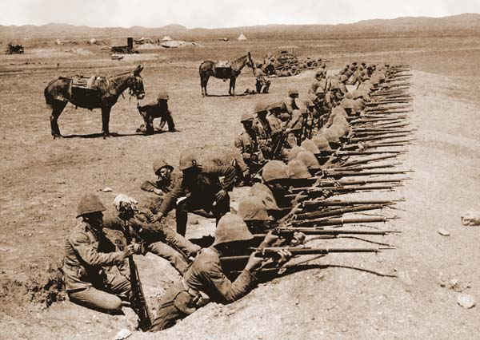4. What was the first war that Canadians fought in during the 20th century (1900’s)?

A. Boer War

B. Civil War

C. First World War

D. Korean War

5. What was a special tax that only Chinese immigrants had to pay in order to enter Canada?

1. Abolution tax

B. Head tax

C. Immigration tax

D. Income tax

6. What is the right for women to vote and hold elected office?

A. Enfranchisement

B. National Council of Women

C. Suffrage

D. Women Temperance League

7. What was the name of the first international agreement that Canada negotiated and signed on its own behalf in 1923?

A. Balfour Report

B. Halibut Treaty

C. Salmon Treaty

D. Statute of Westminster

8. What government policy encouraged aboriginals to abandon their native culture?

A. Assimilation

B. Emigration

C. Genocide

D. Immigration

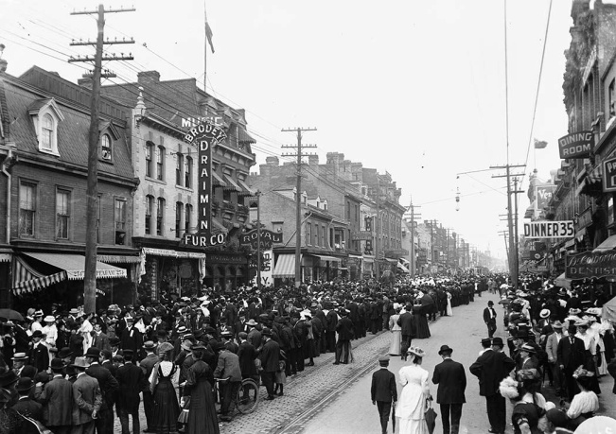9. What word best describes the movement of people from small towns into the cities like Toronto, shown here in 1900?

A. Citification

B. Ruralization

C. Translocation

D. Urbanization

10. Which country **was not** a member of the Triple Alliance during World War 1?

A. Germany

B. Russia

C. Italy

D. Austria Hungary

11. Which issue caused considerable controversy in Quebec during World War I?

A. Conscription

B. Louis Riel Rebellion

C. Reciprocity

D. Pacifism

12. Which of the following best describes the area called No Man’s Land?

A. The battle line in Eastern Europe and the Balkans.

B. The deadly territory between opposing trenches.

C. The German route of invasion through Belgium

D. The peninsula of France

13. Which event is considered to be the direct cause of the First World War?

A. Assassination of Archduke Franz Ferdinand

B. Austria-Hungary declaring war on Serbia

C. German invasion of Poland

D. Germany declaring war on France

14. Which event directly led the United States entering the First World War?

1. Assassination of Franz Ferdinand

B. German war crimes in Belgium

C. Sinking of the Lusitania

D. Zimmerman Telegram



15. Based on the photo shown, what impact did the First World War have on social conditions for women in Canada?

1. They were called upon to take non-traditional roles
2. They were expected to have more children
3. They were expected to work in agriculture
4. They were not expected to contribute to the war effort

16. What was the result of Trench Warfare in WWI?

1. It caused a stalemate which resulted in a long war
2. It caused the war to be over very quickly
3. It helped the French and British

D. It helped the Germans and United States

1. What was the purpose of German Schlieffen Plan?

1. A blockade of France to starve that country into submission.
2. A quick invasion of Great Britain and destruction of the British navy.
3. A quick invasion of Russia so that the war would only be fought on one front.

D. A swift knockout of France combined with defensive action against Russia.

1. Which WWI battle devastated the Newfoundland Regiment?

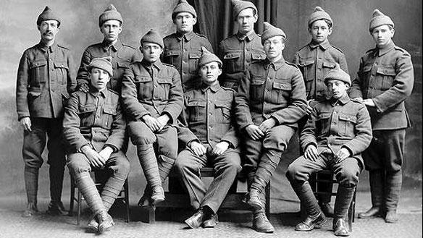

A. Beaumont Hamel

B. Bunker Hill

C. Vimy Ridge

D. Ypres

19. November 11, 1918 is remembered today for what important event?

A. Britain declared war on Germany

B. England surrendered and ended World War I

C. Germany signed the armistice

D. The Treaty of Versailles was signed

20. Which economic system has a free market system with open competition for profits?

A. Capitalism

B. Communism

C. Democracy

D. Socialism

21. What term refers to taxes placed on goods that are imported to a country?

A. Relief

B. Staples

C. Stocks

D. Tariffs

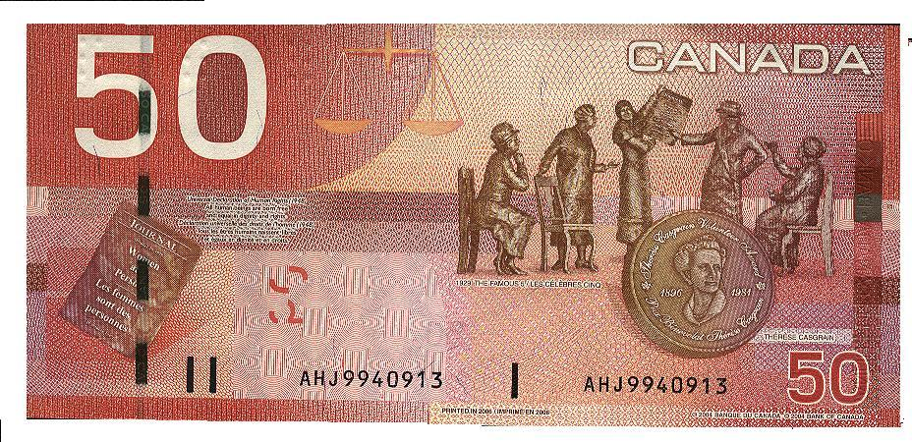22. What court case, remembered here on the $50 bill, did Emily Murphy and four other women petition all the way to the British Supreme Court?

A. British North American Act

B. Canadian Act

C. Person’s Case

D. Women’s Case

23. Which best describes the condition of Relief Camps in Canada during the Great Depression?

A. A place for men and women to find successful employment

B. A place that families could be comfortable

C. Men were well paid with good working and living conditions

D. Men were poorly paid with bad working and living conditions

24. What event occurred during “The Ottawa Trek” by order of Prime Minister Bennett?

A. The police helped the trekkers on their way to Ottawa

B. The police stopped the trekkers in Regina and a riot occurred

C. The Prime Minster listened to the concerns of the trekkers

D. The Trekkers made it to Ottawa to voice their concerns to Bennett.

25. What event made most Canadians want to enter the Second World War?

A. Battle of Hong Kong

B. Germany’s attack on Poland

C. Japan’s attack on Pearl Harbor

D. Sinking of the Athenia

26. What alliance was Canada a part of during the Second World War?

A. Allied Powers

B. Axis Powers

C. British Common Wealth

D. British Empire

27. Who was the leader of the National Socialist Party in Germany?

A. Adolf Hitler

B. Benito Mussolini

C. Mackenzie King

D. Winston Churchill

28. What battle saw the Canadian force suffer high causality rates by Japanese forces?

A. Battle of the Atlantic

B. Battle of Britain

C. Battle of Dieppe

D. Battle of Hong Kong

1. What new invention helped the British defend against air raids by the German Air Force?
2. Guns
3. Missiles
4. Radar
5. Tanks
6. 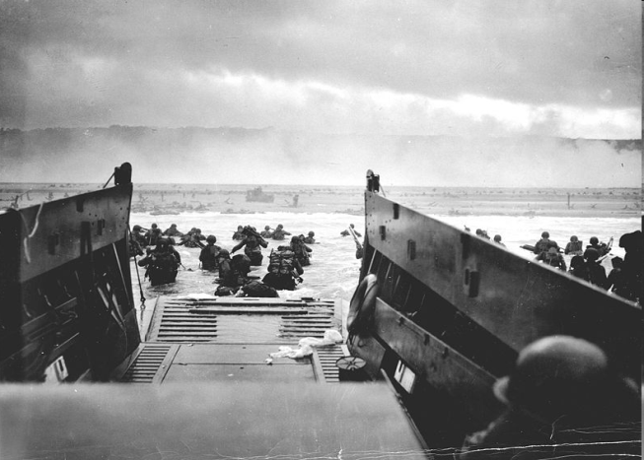With reference to the picture below, what Battle is considered the turning point of the Second World War?

A. Battle of the Atlantic

B. Battle of Britain

C. Battle of Sicily

D. D-Day Invasion

1. For what reason were the airports and bases built in Gander and Goose Bay during the Second World War?

A. Ferry Command

B. Passenger Service

C. Convoy covering

D. Training Canada pilots

1. With reference to picture below, how were Canadians of Japanese decent dealt with during the Second World War?

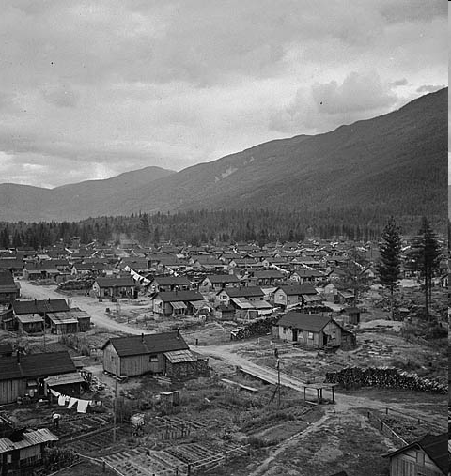

A. Sent to Jail

B. Forced into Poverty

C. Put into Internment Camps

D. Made into Refugees

1. With reference to the picture below, what was Canada’s response to allowing Jewish Refugees from Germany entrance into the country?

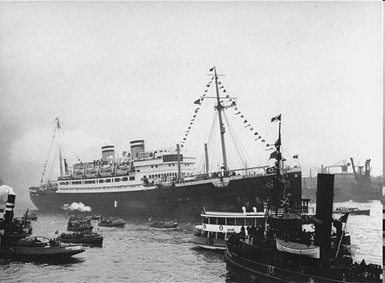

A. Granted Refugee status

B. Granted Visas

C. Refused entry into Canada

D. Refused entry into Nova Scotia

1. Which of the following was the long standing leader of Quebec’s Union Nationale party and the Premier of the Province?

A. J.S. Woodsworth

B. Maurice Duplessis

C. Maurice Richard

D. Rene Levesque

1. What group(s) rejected the conscription Plebiscite by Mackenzie King?

A. English Canadians

B. English and French Canadians

C. French Canadians

D. Japanese Canadians

1. What major change occurred for women during the Second World War?

A. Joined the Canadian army, navy and air force

B. Joined the British army, navy and air force

C. Worked in factories

D. Worked as nurse

1. 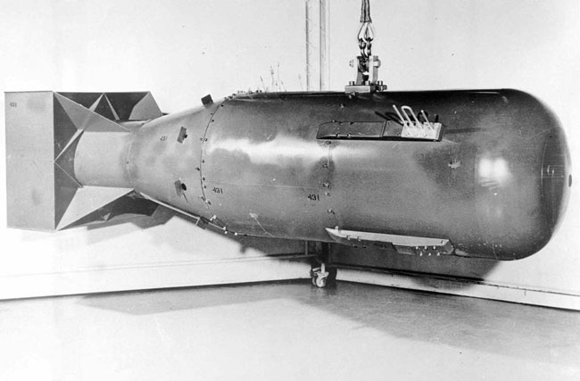What name was given to the project that involved several scientists working to develop the atomic bomb?

A. Bronx Project

B. Brooklyn Project

C. Manhattan Project

D. Queens Project

38. What symbol did Lester Pearson want to create to help strengthen Canada’s identity?

A. Appeasement with Quebec

B. Communism with USA

C. National Flag for Canada

D. Socialism for all of Canada

39. What was the period of increased tension between the Soviet Union and democratic countries after the Second World War?

A. Cold War

B. Cuban Missile Crisis

C. Detent

D. Quiet Revolution



40. What was the name of the new international organization to support world peace which was created after World War II?

A. Allied Nations

B. Allied League

C. League of Nations

D. United Nations

41. What organization was created to protect against Soviet expansion into Western Europe?

A. Atlantic Powers

B. Allied Powers

C. North Atlantic Treaty Organization

D. North American Defense Treaty

42. What is the proper acronym for the North American Air Defense System ?

A. NAADS

B. NADA

C. NATO

D. NORAD

43. Which of the following refers to strong federal control over Canada ?

A. Centralized Power

B. Decentralize Power

C. Majority Government

D. Minority Government

44. What was the name of the payments given to provinces by the Federal government to help

pay for health care, education and other essential services?

A. Adjustment Payments

B. Equilization Payments

C. Service Payments

D. Workman’s Compensation

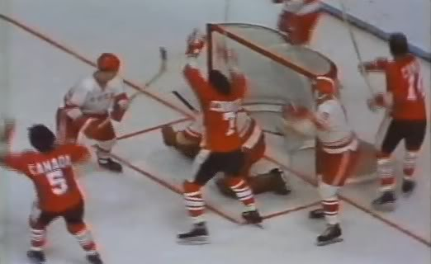45. Which Team Canada member scored the Game winning goal in the 1972 Summit Series?

A. Harold Cardinal

B. Paul Henderson

C. Patrick Roy

D. Wayne Gretzky

46. Which part of the United Nations includes representatives from each member-state, and allows every member to have a vote?

1. General Assembly
2. International Court
3. Secretariat
4. Security Council

47. Which Prime Minister of Canada helped solve the Suez Crisis and became Canada’s first recipient of the Nobel Peace Prize ?

A. Brian Mulroney

B. John Diefenbaker

C. Lester B. Pearson

D. Mackenzie King

48. Which of the following was Canada’s only woman Prime Minister?

A. Adrienne Clarkson

B. Jean Sauve

C. Kim Campbell

D. Marie LeClaire

49. What was the result of the Quebec Referendum in 1995?

1. Majority Yes Vote
2. Majority No Vote
3. Quebec left Canada
4. Quebec left NATO

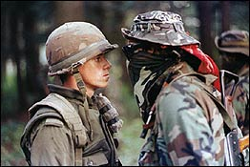 50. Which of the following was the reason for the Oka Crises with Mohawk First Nations in Quebec?

A. Civil War

B. Land dispute

C. October Crises

D. Quebec Referendum

**Section C: Essay Questions Value 50%**

**Value 13 marks**

51. The causes of wars usually do not change. Using examples from both major wars of the 20th century, show how the underlying causes were very similar for both of the World Wars.

__________________________________________________________________________________________________________________________________________________________________________________________________________________________________________________________________________________________________________________________________________________________________________________________________________________________________________________________________________________________________________________________________________________________________________________________________________________________________________________________________________________________________________________________________________________________________________________________________________________________________________________________________________________________________________________________________________________________________________________________________________________________________________________________________________________________________________________________________________________________________________________________________________________________________________________________________________________________________________________________________________________________________________________________________________________________________________________________________________________________________________________________________________________________________________________________________________________________________________________________________________________________________________________________________________________________________________________________________________________________________________________________________________________________________________________________________________________________________________________________________________________________________________________________________________________________________________________________________________________________________________________________________________________________________________________________________________________________________________________________________________________________________________________________________________________________________________________________________________________________________________________________________________________________________________________________________________________________________________________________________________________________________________________________________________________________________________________________________________________________________________________________________________________________________________________________________________________________________________________________________________________________________________________________________________________________________________________________________________________________________________________________________________________________________________________________________________________________________________________________________________________________________________________________________________________________________________________________________________________________

__________________________________________________________________________________________________________________________________________________________________________________________________________________________________________________________________________________________________________________________________________________________________________________________________________________________________________________________________________________________________________________________________________________________________

__________________________________________________________________________________________________________________________________________________________________________________________________________________________________________________________________________________________________________________________________________________________________________________________________________________________________________________________________________________________________________________________________________________________________________________________________________________________________________________________________________________________________________________________________________________________________________________________________________________________________________________________________________________________________________________________________________________________________________________________________________________________________________________________________________________________________________________________________________________________________________________________________________________________________________________________________________________________________________________________________________________________________________________________________________________________________________________________________________________________________________________________________________________________________________________________________________________________________________________________________________________________________________________________________________________________________________________________________________________________________________________________________

**Value 12 marks**

52. What were the events that led to the vote by Newfoundlanders to leave the British Commissional leadership and join with the Canadian Confederation in 1949. Describe the conditions in Newfoundland before and after World War 2, who led the campaign to join Canada, and why Newfoundlanders would be willing to vote to join Confederation.

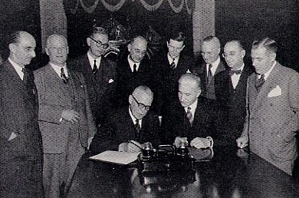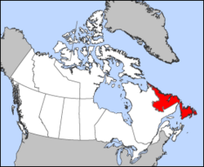

______________________________________________________________________________________________________________________________________________________________________________________________________________________________________________________________________________________________________________________________________________________________________________________________________________________________________________________________________________________________________________________________________________________________________________________________________________________________________________________________________________________________________________________________________________________________________________________________________________________________________________________________________________________________________________________________________________________________________________________________________________________________________________________________________________________________________________________________________________________________________________________________________________________________________________________________________________________________________________________________________________________________________________________________________________________________________________________________________________________________________________________________________________________________________________________________________________________________________________________________________________________________________________________________________________________________________________________________________________________________________________________________________________________________________________________________________________________________________________________________________________________________________________________________________________________________________________________________________________________________________________________________________________________________________________________________________________________________________________________________________________________________________________________________________________________________________________________________________________________________________________________________________________________________________________________________________________________________________________________________________________________________________________________________________________________________________________________________________________________________________________________________________________________________________________________________________________________________________________________________________________________________________________________________________________________________________________________________________________________________________________________________________________________________________________________________________________________________________________________________

__________________________________________________________________________________________________________________________________________________________________________________________________________________________________________________________________________________________________________________________________________________________________________________________________________________________________________________________________________________________________________________________________________________________________

__________________________________________________________________________________________________________________________________________________________________________________________________________________________________________________________________________________________________________________________________________________________________________________________________________________________________________________________________________________________________________________________________________________________________

____________________________________________________________________________________________________________________________________________________________________________________________________________________________________________________________________________________________________________________________________________________________________________________________________________________________________________________________________________________

**Value 13 marks**

53. Describe Canada’s record for dealing with minorities, either as immigrants or groups within our country. In your response, give examples of how policies have changed from the 1870’s to the present, especially in times of crisis such as the Great Depression and the World Wars. Some groups you could include would be the Chinese, Japanese, Jews, Blacks and Aboriginals.

____________________________________________________________________________________________________________________________________________________________________________________________________________________________________________________________________________________________________________________________________________________________________________________________________________________________________________________________________________________________________________________________________________________________________________________________________________________________________________________________________________________________________________________________________________________________________________________________________________________________________________________________________________________________________________________________________________________________________________________________________________________________________________________________________________________________________________________________________________________________________________________________________________________________________________________________________________________________________________________________________________________________________________________________________________________________________________________________________________________________________________________________________________________________________________________________________________________________________________________________________________________________________________________________________________________________________________________________________________________________________________________________________________________________________________________________________________________________________________________________________________________________________________________________________________________________________________________________________________________________________________________________________________________________________________________________________________________________________________________________________________________________________________________________________________________________________________________________________________________________________________________________________________________________________________________________________________________________________________________________________________________________________________________________________________________________________________________________________________________________________________________________________________________________________________________________________________________________________________________________________________________________________________________________________________________________________________________________________________________________________________________________________________________________________________________________________________________________________________________________________________________________________________________________________________________________________________________________________________________________________________________________________________________________________________________________________________________________________________________________________________________________________________________________________________________________________________________________________________________________________________________________________________________________________________________________________________________________________________________________________________________________________________________________________________________________________________________________________________________________________________________________________________________________________________________________________________________________________________________________________________________________________________________________________________________________________________________________________________________________________________________________________________________________________________________________________________________________________________________________________________________________________________________________________________________________________________________________________________________________________________________________________________________________________________________________________________________________________________________________________________________________________________________________________________________________________________________________________________________________________________________________________________________________________________________________________________________________________________________________________________________________________________________________________________________________________________________________________________________________________________________________________________________________________________________________________________________________________________________________________________________

**Value 12 marks**

54. Relations between French and English Canada has been an ongoing struggle for our country. With references to the Union Nationale, the Quiet Revolution, the Parti Quebecois and the Bloc Quebecois, describe how the state of Quebec politics and the province’s relationship with Canada changed during the 20th century?

________________________________________________________________________________________________________________________________________________________________________________________________________________________________________________________________________________________________________________________________________________________________________________________________________________________________________________________________________________________________________________________________________________________________________________________________________________________________________________________________________________________________________________________________________________________________________________________________________________________________________________________________________________________________________________________________________________________________________________________________________________________________________________________________________________________________________________________________________________________________________________________________________________________________________________________________________________________________________________________________________________________________________________________________________________________________________________________________________________________________________________________________________________________________________________________________________________________________________________________________________________________________________________________________________________________________________________________________________________________________________________________________________________________________________________________________________________________________________________________________________________________________________________________________________________________________________________________________________________________________________________________________________________________________________________________________________________________________________________________________________________________________________________________________________________________________________________________________________________________________________________________________________________________________________________________________________________________________________________________________________________________________________________________________________________________________________________________________________________________________________________________________________________________________________________________________________________________________________________________________________________________________________________________________________________________________________________________________________________________________________________________________________________________________________________________________________________________________________________________________________________________________________________________________________________________________________________________________________________________________________________________________________________________________________________________________________________________________________________________________________________________________________________________________________________________________________________________________________________________________________________________________________________________________________________________________________________________________________________________________________________________________________________________________________________________________________________________________________________________________________________________________________________________________________________________________________________________________________________________________________________________________________________________________________________________________________________________________________________________________________________________________________________________________________________________________________________________________________________________________________________________________________________________________________________________________________________________________________________________________________________________________________________________________________________________________________________________________________________________________________________________________________________________________________________________________________________________________________________________________________________________________________________________________________________________________________________________________________________________________________________________________________________________________________________________________________________________________________________________________________________________________________________________________________________________________________________________________________________________________________________________________________________________________________________________________________________________________________________________________________________