

**Mealy Mountain Collegiate**

**Canadian History**

**Supplemental Exam**

**2014**

Student: ________________________

**Instructions**

**Part 1: 40 Selected Response Items 50%**

**P**ut the letter of the correct response on the answer sheet provided.

**Part 2. 4 Constructed Response Items 50%**

**A**nswer all questions in the spaces provided on the exam.

**Canadian History Final Exam**

Response Sheet

* Put you name on this sheet and you may remove it from your test
* Circle the letter of the best response for each question.

Student Name: ____________________

1. A B C D
2. A B C D
3. A B C D
4. A B C D
5. A B C D
6. A B C D
7. A B C D
8. A B C D
9. A B C D
10. A B C D
11. A B C D
12. A B C D
13. A B C D
14. A B C D
15. A B C D
16. A B C D
17. A B C D
18. A B C D
19. A B C D
20. A B C D
21. A B C D
22. A B C D
23. A B C D
24. A B C D
25. A B C D
26. A B C D
27. A B C D
28. A B C D
29. A B C D
30. A B C D
31. A B C D
32. A B C D
33. A B C D
34. A B C D
35. A B C D
36. A B C D
37. A B C D
38. A B C D
39. A B C D
40. A B C D

1. What is a policy of establishing colonies away from the homeland and building an empire?



1. Imperialism

B. Nation Building

C. Nation Policy

D. Socialism

2. What was the Act of the Federal Government that granted land to Canadian settlers?

A. BNA Act

B. Homestead Act

C. Manitoba Act

D. Zone Act

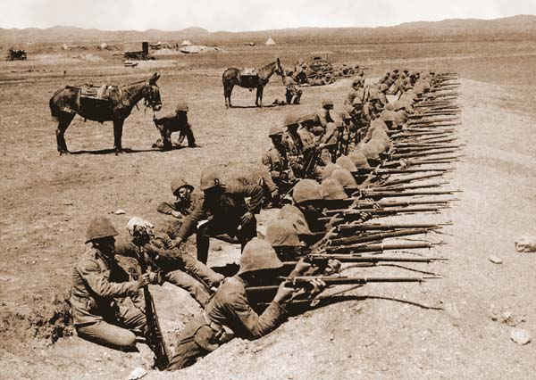3. What was the first war that Canadians fought in during the 20th century (1900’s)?

A. Boer War

B. Civil War

C. First World War

D. Korean War

4. What was a special tax that only Chinese immigrants had to pay in order to enter Canada?

1. Abolution tax

B. Head tax

C. Immigration tax

D. Income tax

5. What is the right for women to vote and hold elected office?

A. Enfranchisement

B. National Council of Women

C. Suffrage

D. Women Temperance League

6. What government policy encouraged aboriginals to abandon their native culture?

A. Assimilation

B. Emigration

C. Genocide

D. Immigration

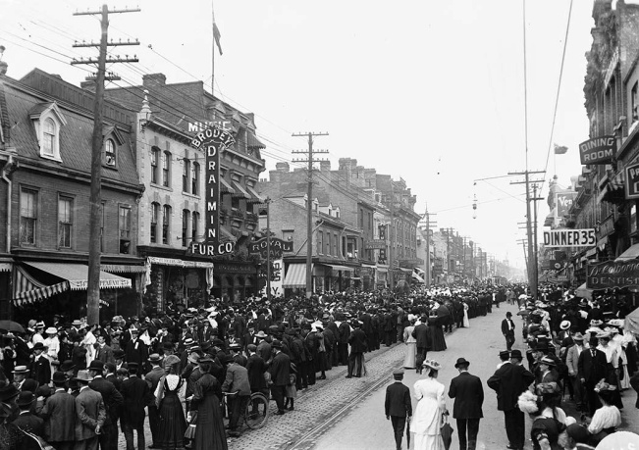7. What word best describes the movement of people from small towns into the cities like Toronto, shown here in 1900?

A. Citification

B. Ruralization

C. Translocation

D. Urbanization

8. Which country **was** a member of the Triple Entente during World War 1?

A. Germany

B. Russia

C. Italy

D. Austria Hungary

9. Which issue caused considerable controversy in Quebec during World War I?

A. Conscription

B. Louis Riel Rebellion

C. Reciprocity

D. Pacifism

10. Which of the following best describes the area called No Man’s Land?

A. The battle line in Eastern Europe and the Balkans.

B. The deadly territory between opposing trenches.

C. The German route of invasion through Belgium

D. The peninsula of France

11. Which event is considered to be the direct cause of the First World War?

A. Assassination of Archduke Franz Ferdinand

B. Austria-Hungary declaring war on Serbia

C. German invasion of Poland

D. Germany declaring war on France

12. Which event directly led the United States entering the First World War?

1. Assassination of Franz Ferdinand

B. German war crimes in Belgium

C. Sinking of the Lusitania

D. Zimmerman Telegram

13. Based on the photo shown, what impact did the First World War have on social conditions for women in Canada?

1. They were called upon to take non-traditional roles
2. They were expected to have more children
3. They were expected to work in agriculture
4. They were not expected to contribute to the war effort

14. What was the result of Trench Warfare in WWI?

1. It caused a stalemate which resulted in a long war
2. It caused the war to be over very quickly
3. It helped the French and British

D. It helped the Germans and United States

1. Which WWI battle devastated the Newfoundland Regiment?

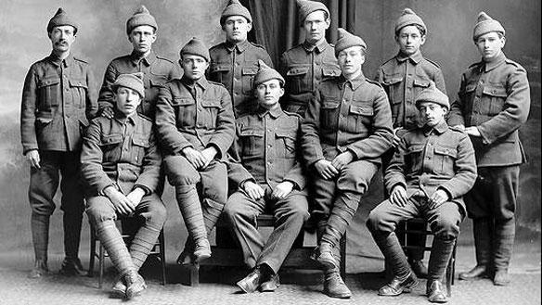

A. Beaumont Hamel

B. Bunker Hill

C. Vimy Ridge

D. Ypres

16. November 11, 1918 is remembered today for what important event?

A. Britain declared war on Germany

B. England surrendered and ended World War I

C. Germany signed the armistice

D. The Treaty of Versailles was signed

17. Which economic system has a free market system with open competition for profits?

A. Capitalism

B. Communism

C. Democracy

D. Socialism

18. What term refers to taxes placed on goods that are imported to a country?

A. Relief

B. Staples

C. Stocks

D. Tariffs

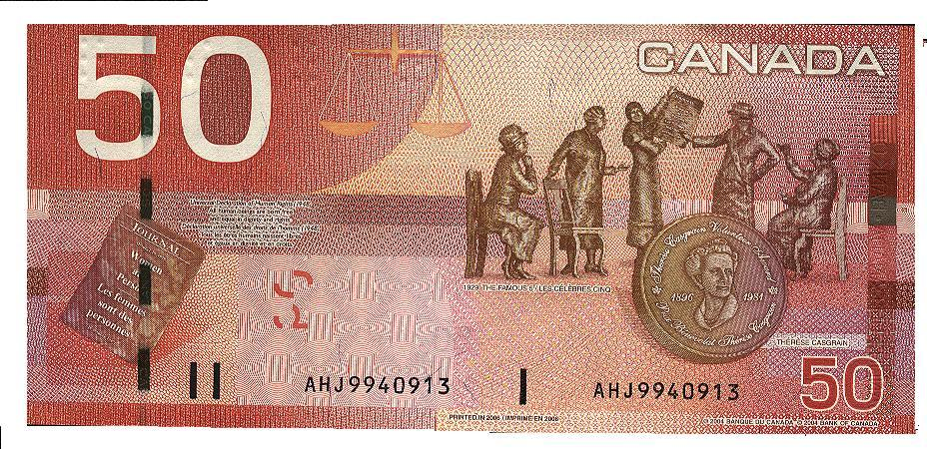19. What court case, remembered here on the $50 bill, did Emily Murphy and four other women petition all the way to the British Supreme Court?

A. British North American Act

B. Canadian Act

C. Person’s Case

D. Women’s Case

20. Which best describes the condition of Relief Camps in Canada during the Great Depression?

A. A place for men and women to find successful employment

B. A place that families could be comfortable

C. Men were well paid with good working and living conditions

D. Men were poorly paid with bad working and living conditions

21. What event occurred during “The Ottawa Trek” by order of Prime Minister Bennett?

A. The police helped the trekkers on their way to Ottawa

B. The police stopped the trekkers in Regina and a riot occurred

C. The Prime Minster listened to the concerns of the trekkers

D. The Trekkers made it to Ottawa to voice their concerns to Bennett.

22. What alliance was Canada a part of during the Second World War?

A. Allied Powers

B. Axis Powers

C. British Common Wealth

D. British Empire

23. Who was the leader of the National Socialist Party in Germany?

A. Adolf Hitler

B. Benito Mussolini

C. Mackenzie King

D. Winston Churchill

24. What battle saw the Canadian force suffer high causality rates by Japanese forces?

A. Battle of the Atlantic

B. Battle of Britain

C. Battle of Dieppe

D. Battle of Hong Kong

1. What new invention helped the British defend against air raids by the German Air Force?
2. Guns
3. Missiles
4. Radar
5. Tanks
6. 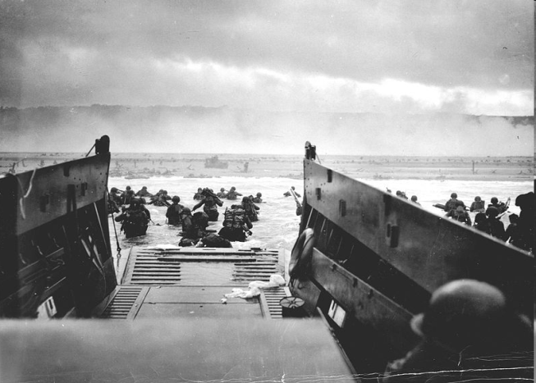With reference to the picture below, what Battle is considered the turning point of the Second World War?

A. Battle of the Atlantic

B. Battle of Britain

C. Battle of Sicily

D. D-Day Invasion

1. For what reason were the airports and bases built in Gander and Goose Bay during the Second World War?

A. Ferry Command

B. Passenger Service

C. Convoy covering

D. Training Canada pilots

1. With reference to picture below, how were Canadians of Japanese decent dealt with during the Second World War?

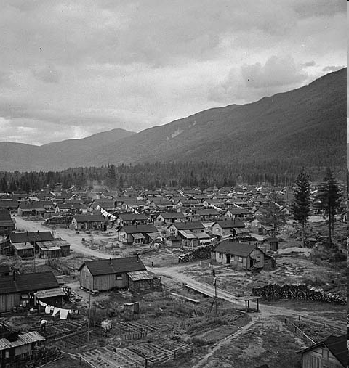

A. Sent to Jail

B. Forced into Poverty

C. Put into Internment Camps

D. Made into Refugees

1. With reference to the picture below, what was Canada’s response to allowing Jewish Refugees from Germany entrance into the country?

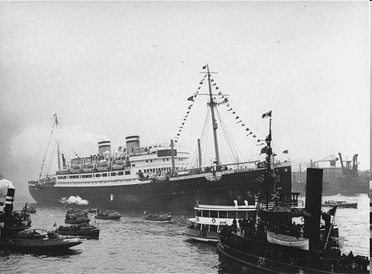

A. Granted Refugee status

B. Granted Visas

C. Refused entry into Canada

D. Refused entry into Nova Scotia

1. Which of the following was the long standing leader of Quebec’s Union Nationale party and the Premier of the Province?

A. J.S. Woodsworth

B. Maurice Duplessis

C. Maurice Richard

D. Rene Levesque

1. What group(s) rejected the conscription Plebiscite by Mackenzie King?

A. English Canadians

B. English and French Canadians

C. French Canadians

D. Japanese Canadians

1. What major change occurred for women during the Second World War?

A. Joined the Canadian army, navy and air force

B. Joined the British army, navy and air force

C. Worked in factories

D. Worked as nurse

1. 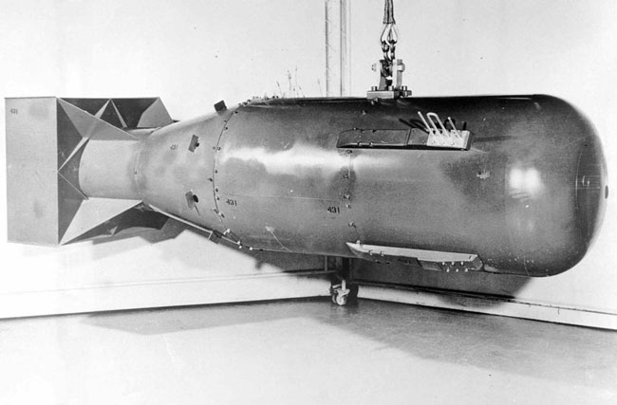What name was given to the project that involved several scientists working to develop the atomic bomb?

A. Bronx Project

B. Brooklyn Project

C. Manhattan Project

D. Queens Project

34. What symbol did Lester Pearson want to create to help strengthen Canada’s identity?

A. Appeasement with Quebec

B. Communism with USA

C. National Flag for Canada

D. Socialism for all of Canada

35. What was the period of increased tension between the Soviet Union and democratic countries after the Second World War?

A. Cold War

B. Cuban Missile Crisis

C. Detent

D. Quiet Revolution



36. What was the name of the new international organization to support world peace which was created after World War II?

A. Allied Nations

B. Allied League

C. League of Nations

D. United Nations

37. What organization was created to protect against Soviet expansion into Western Europe?

A. Atlantic Powers

B. Allied Powers

C. North Atlantic Treaty Organization

D. North American Defense Treaty

38. What is the proper acronym for the North American Air Defense System ?

A. NAADS

B. NADA

C. NATO

D. NORAD

39. What was the name of the payments given to provinces by the Federal government to help

pay for health care, education and other essential services?

A. Adjustment Payments

B. Equilization Payments

C. Service Payments

D. Workman’s Compensation

40. Which Prime Minister of Canada helped solve the Suez Crisis and became Canada’s first recipient of the Nobel Peace Prize ?

A. Brian Mulroney

B. John Diefenbaker

C. Lester B. Pearson

D. Mackenzie King

**Section C: Essay Questions Value 50%**

**Value 13 marks**

51. The causes of wars usually do not change. Using examples from both major wars of the 20th century, show how the underlying causes were very similar for both of the World Wars.

__________________________________________________________________________________________________________________________________________________________________________________________________________________________________________________________________________________________________________________________________________________________________________________________________________________________________________________________________________________________________________________________________________________________________________________________________________________________________________________________________________________________________________________________________________________________________________________________________________________________________________________________________________________________________________________________________________________________________________________________________________________________________________________________________________________________________________________________________________________________________________________________________________________________________________________________________________________________________________________________________________________________________________________________________________________________________________________________________________________________________________________________________________________________________________________________________________________________________________________________________________________________________________________________________________________________________________________________________________________________________________________________________________________________________________________________________________________________________________________________________________________________________________________________________________________________________________________________________________________________________________________________________________________________________________________________________________________________________________________________________________________________________________________________________________________________________________________________________________________________________________________________________________________________________________________________________________________________________________________________________________________________________________________________________________________________________________________________________________________________________________________________________________________________________________________________________________________________________________________________________________________________________________________________________________________________________________________________________________________________________________________________________________________________________________________________________________________________________________________________________________________________________________________________________________________________________________________________________________________________

__________________________________________________________________________________________________________________________________________________________________________________________________________________________________________________________________________________________________________________________________________________________________________________________________________________________________________________________________________________________________________________________________________________________________

__________________________________________________________________________________________________________________________________________________________________________________________________________________________________________________________________________________________________________________________________________________________________________________________________________________________________________________________________________________________________________________________________________________________________________________________________________________________________________________________________________________________________________________________________________________________________________________________________________________________________________________________________________________________________________________________________________________________________________________________________________________________________________________________________________________________________________________________________________________________________________________________________________________________________________________________________________________________________________________________________________________________________________________________________________________________________________________________________________________________________________________________________________________________________________________________________________________________________________________________________________________________________________________________________________________________________________________________________________________________________________________________________

**Value 12 marks**

52. Compare the organization of the United Nations group with the earlier League of Nations. What makes the United Nations so much more effective as a world organization than its predecessor. Give examples that demonstrate the failure of the League of Nations compared to the success of the United Nations.



______________________________________________________________________________________________________________________________________________________________________________________________________________________________________________________________________________________________________________________________________________________________________________________________________________________________________________________________________________________________________________________________________________________________________________________________________________________________________________________________________________________________________________________________________________________________________________________________________________________________________________________________________________________________________________________________________________________________________________________________________________________________________________________________________________________________________________________________________________________________________________________________________________________________________________________________________________________________________________________________________________________________________________________________________________________________________________________________________________________________________________________________________________________________________________________________________________________________________________________________________________________________________________________________________________________________________________________________________________________________________________________________________________________________________________________________________________________________________________________________________________________________________________________________________________________________________________________________________________________________________________________________________________________________________________________________________________________________________________________________________________________________________________________________________________________________________________________________________________________________________________________________________________________________________________________________________________________________________________________________________________________________________________________________________________________________________________________________________________________________________________________________________________________________________________________________________________________________________________________________________________________________________________________________________________________________________________________________________________________________________________________________________________________________________________________________________________________________________________________________

__________________________________________________________________________________________________________________________________________________________________________________________________________________________________________________________________________________________________________________________________________________________________________________________________________________________________________________________________________________________________________________________________________________________________

__________________________________________________________________________________________________________________________________________________________________________________________________________________________________________________________________________________________________________________________________________________________________________________________________________________________________________________________________________________________________________________________________________________________________

____________________________________________________________________________________________________________________________________________________________________________________________________________________________________________________________________________________________________________________________________________________________________________________________________________________________________________________________________________________

**Value 13 marks**

53. Describe Canada’s record for dealing with minorities, either as immigrants or groups within our country. In your response, give examples of how policies have changed from the 1870’s to the present, especially in times of crisis such as the Great Depression and the World Wars. Some groups you could include would be the Chinese, Japanese, Jews, Blacks and Aboriginals.

____________________________________________________________________________________________________________________________________________________________________________________________________________________________________________________________________________________________________________________________________________________________________________________________________________________________________________________________________________________________________________________________________________________________________________________________________________________________________________________________________________________________________________________________________________________________________________________________________________________________________________________________________________________________________________________________________________________________________________________________________________________________________________________________________________________________________________________________________________________________________________________________________________________________________________________________________________________________________________________________________________________________________________________________________________________________________________________________________________________________________________________________________________________________________________________________________________________________________________________________________________________________________________________________________________________________________________________________________________________________________________________________________________________________________________________________________________________________________________________________________________________________________________________________________________________________________________________________________________________________________________________________________________________________________________________________________________________________________________________________________________________________________________________________________________________________________________________________________________________________________________________________________________________________________________________________________________________________________________________________________________________________________________________________________________________________________________________________________________________________________________________________________________________________________________________________________________________________________________________________________________________________________________________________________________________________________________________________________________________________________________________________________________________________________________________________________________________________________________________________________________________________________________________________________________________________________________________________________________________________________________________________________________________________________________________________________________________________________________________________________________________________________________________________________________________________________________________________________________________________________________________________________________________________________________________________________________________________________________________________________________________________________________________________________________________________________________________________________________________________________________________________________________________________________________________________________________________________________________________________________________________________________________________________________________________________________________________________________________________________________________________________________________________________________________________________________________________________________________________________________________________________________________________________________________________________________________________________________________________________________________________________________________________________________________________________________________________________________________________________________________________________________________________________________________________________________________________________________________________________________________________________________________________________________________________________________________________________________________________________________________________________________________________________________________________________________________________________________________________________________________________________________________________________________________________________________________________________________________________________________________________

**Value 12 marks**

54. Relations between French and English Canada has been an ongoing struggle for our country. With references to the Union Nationale, the Quiet Revolution, the Parti Quebecois and the Bloc Quebecois, describe how the state of Quebec politics and the province’s relationship with Canada changed during the 20th century?

________________________________________________________________________________________________________________________________________________________________________________________________________________________________________________________________________________________________________________________________________________________________________________________________________________________________________________________________________________________________________________________________________________________________________________________________________________________________________________________________________________________________________________________________________________________________________________________________________________________________________________________________________________________________________________________________________________________________________________________________________________________________________________________________________________________________________________________________________________________________________________________________________________________________________________________________________________________________________________________________________________________________________________________________________________________________________________________________________________________________________________________________________________________________________________________________________________________________________________________________________________________________________________________________________________________________________________________________________________________________________________________________________________________________________________________________________________________________________________________________________________________________________________________________________________________________________________________________________________________________________________________________________________________________________________________________________________________________________________________________________________________________________________________________________________________________________________________________________________________________________________________________________________________________________________________________________________________________________________________________________________________________________________________________________________________________________________________________________________________________________________________________________________________________________________________________________________________________________________________________________________________________________________________________________________________________________________________________________________________________________________________________________________________________________________________________________________________________________________________________________________________________________________________________________________________________________________________________________________________________________________________________________________________________________________________________________________________________________________________________________________________________________________________________________________________________________________________________________________________________________________________________________________________________________________________________________________________________________________________________________________________________________________________________________________________________________________________________________________________________________________________________________________________________________________________________________________________________________________________________________________________________________________________________________________________________________________________________________________________________________________________________________________________________________________________________________________________________________________________________________________________________________________________________________________________________________________________________________________________________________________________________________________________________________________________________________________________________________________________________________________________________________________________________________________________________________________________________________________________________________________________________________________________________________________________________________________________________________________________________________________________________________________________________________________________________________________________________________________________________________________________________________________________________________________________________________________________________________________________________________________________________________________________________________________________________________________________________________________________________________________