Chapter 2 Test

Scale & Proportion Diagrams
Name: Date:
- A playhouse is made as a scale model of the family’s home. 2 m represent 0.25 m. If the house is 8 metres by 12 metres, what are the dimensions of the model?
  - 0.8 m by 0.12 m
  - 1.0 m by 1.5 m
  - 2.0 m by 3.0 m
  - 4.0 m by 6.0 m
- Dave carves and sells models of Dories for tourists. One of his models has a scale of 1:8. If the model is 30 cm long, how long is the Dory that the model represents?
  - 8 cm
  - 30 cm
  - 240 cm
  - 300 cm
For the next two questions, refer to the diagram shown.
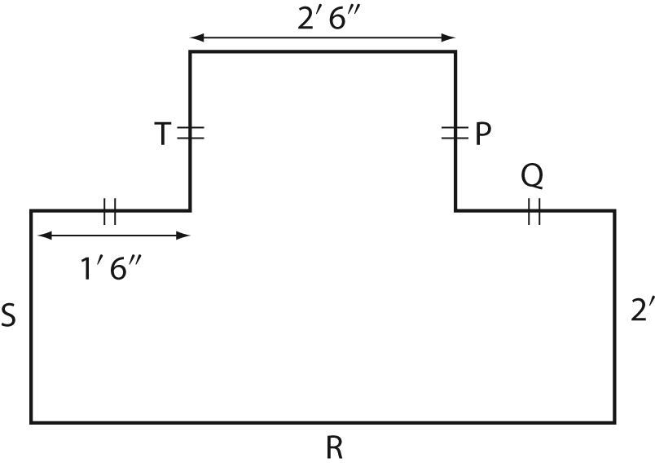
- What is the length of the side ‘Q’ ?
  - 1’ 6”
  - 2’ 6”
  - 3’ 0”
  - 4’ 6”
- What is the length of the side ‘R’ ?
  - 3’ 6”
  - 4’ 6”
  - 5’ 6”
  - 6’ 6”

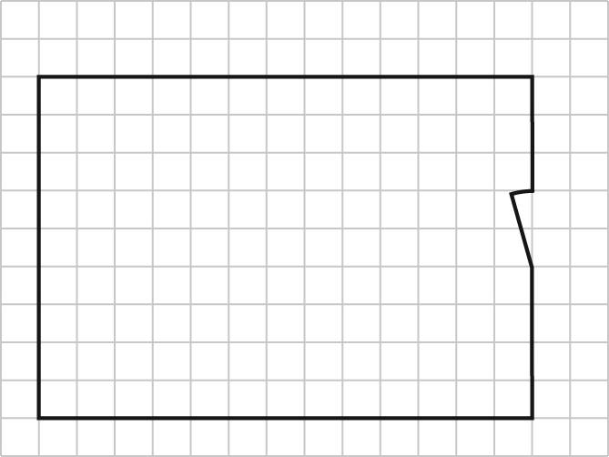
- You have floor tiles that are 0.5 m by 0.5 m. How many tiles do you need to cover the floor of the room if one square on the diagram represents 1 m.
  - 58.5 m
  - 117 m
  - 120 m
  - 234 m

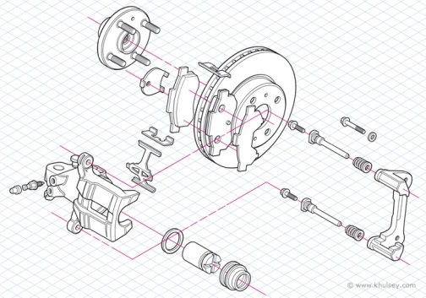
- Here is a diagram of a car’s brake assembly. What type of drawing is this?
  - Exploded view diagram
  - Isometric drawing
  - One-point perspective drawing
  - Orthographic drawing

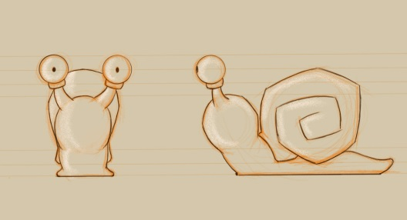
- This is a design page for a animated movie character. What type of drawing is this diagram?
  - Exploded view diagram
  - Isometric drawing
  - One-point perspective drawing
  - Orthographic drawing

- What type of drawing method was used to create this diagram?
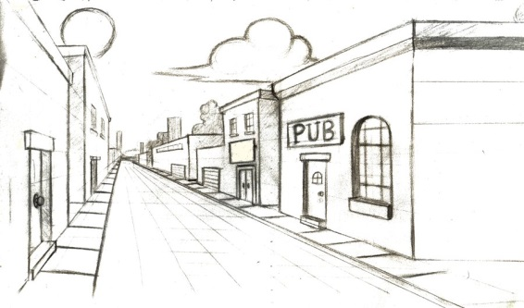
  - Exploded view diagram
  - Isometric drawing
  - One-point perspective drawing
  - Orthographic drawing

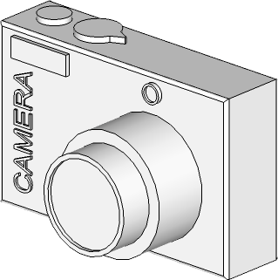
- What type of drawing is this diagram of a camera?
  - Exploded view diagram
  - Isometric drawing
  - One-point perspective drawing
  - Orthographic drawing

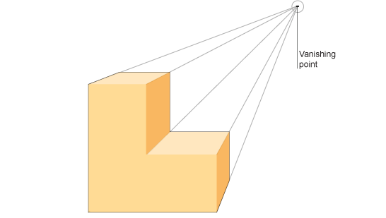
- Identify which type of point of perspective is used in this drawing.
  - Lower right
  - Lower left
  - Upper right
  - Upper left

Constructed Responses
- Sketch the front, side and top views of the truck shown. Be sure to label each sketch you make.
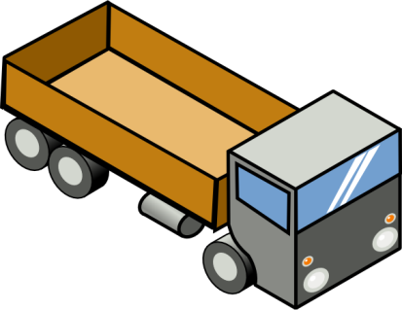

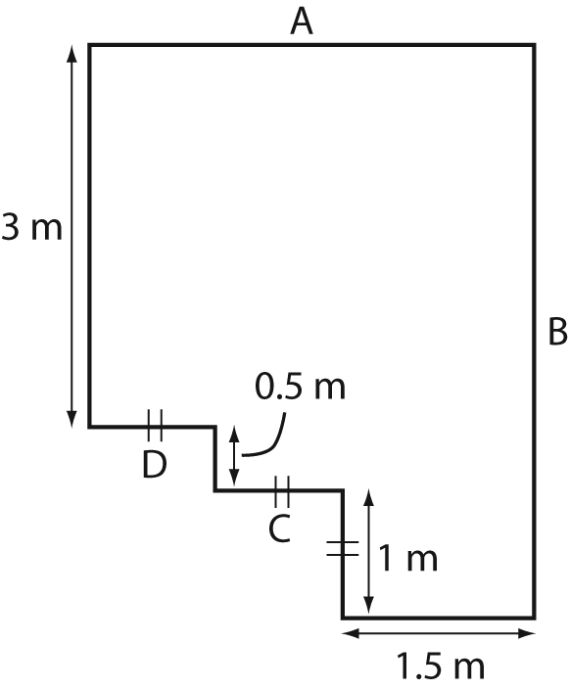
- A) Determine the lengths of A, B, C, and D on the diagram.
A = __________ B = __________
C = __________ D = __________
B) Determine the total perimeter of the figure

- Given the top, front and side views of the object shown, create the isometric drawing of the object on the dot paper provided.
Front

Right

Top

- Draw a Hexagon in upper section of the space below. Choose a point of perspective in the lower right and create a one point perspective drawing using your own vanishing point.

- Create an exploded view of the Big Mac shown.

