Nutrition 3102
Cinnamon Buns
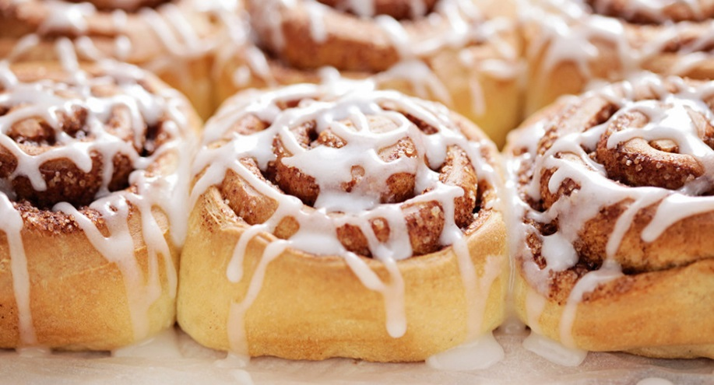
Ingredients
BUNS:
1 Pkg premade dough
¾ cup brown sugar
2 Tbsp cinnamon
Some softened margerine
ICING:
3-4 Tbsp melted margerine
1 cup icing sugar
2 oz cream cheese (1/4 pkg.)
1 tsp. vanilla extract
1-2 Tbsp fresh or carnation milk

Instructions
- Be sure that dough and margarine are warmed to room temperature. You could make your own dough and let rise for 1 ½ hours before this.
- Roll out dough on a clean surface, making a large rectangle
- Spread margarine onto dough
- Sprinkle brown sugar and then cinnamon onto the greased dough
- Carefully roll the sheet of dough into a long log shape.
- Presentation is your choice at this point. Basic method is to cut across the log to make discs that you can put in the pan
- Bake at 350º for 25 min
ICING:
- In a small to medium bowl, mix melted margarine with cream cheese vanilla and icing sugar
- Add milk to bring it to desired consistency.

