**Math 2202**

**Midterm Exam**

**January 2014**

**Student: ____________________**

**General Instructions**

1. Students are required to do ALL items**.**

2. The examinationconsists of the following parts:

Section A**:** 30 Selected Response *Value: 50%*

*Use the answer sheet provided to record all responses*

Section B: Constructed Response *Value: 50%*

*Complete all questions in the space provided, showing all workings for complete marks.*

**DO NOT OPEN THIS EXAMINATION PAPER UNTIL YOU ARE TOLD BY THE SUPERVISOR TO BEGIN**

**Formulas**

**Square Rectangle**

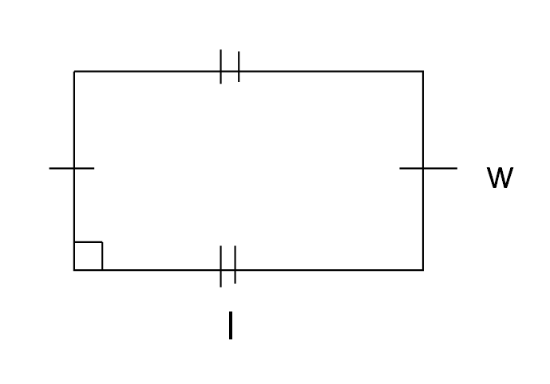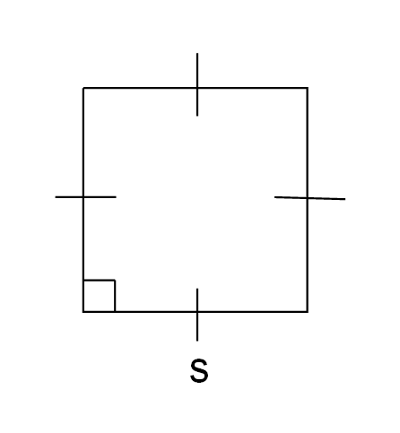

A = s2 A = l x w



**Triangle** **Circle**

 

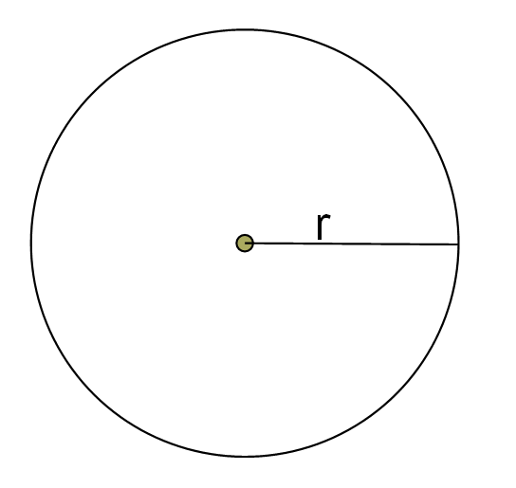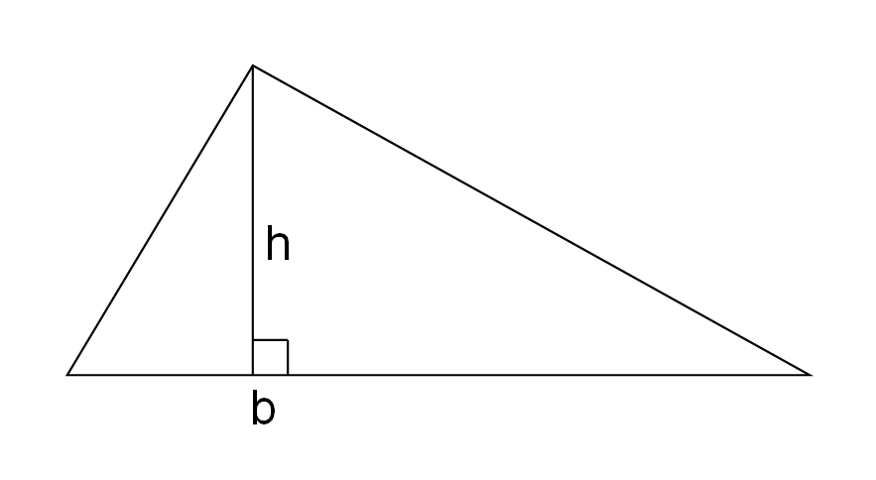

 or 

**Section A - Selected Response (50%)**

**Directions:** Place the letter corresponding to the correct answer on the answer sheet provided.



1. Which is the correct net for this object?



|  |  |
| --- | --- |
| A) |  |
| B) |  |
| C) |  |
| D) |  |



2. Which 3-D object can be made from this net?

1. Rectangular prism

B) Rectangular pyramid

C) Triangular prism

D) Triangular pyramid

3. Which diagram CANNOT be folded to make a cube?

**

A)

**

B)

**

C)



D)

4. This is the net of a right rectangular prism. The area of each face, in square centimeters, is given. What is the surface area of the prism?

A) 178 cm2

B) 174 cm2

C) 228 cm2

D) 348 cm2

5. Calculate the total surface area of the right triangular prism using its net.



A) 147.5 cm2

B) 165.0 cm2

C) 207.5 cm2

D) 225.0 cm2

6. The area of each triangular face of this right triangular prism is 8 cm2. Calculate the total

surface area of the prism.



|  |  |
| --- | --- |
|  |  |

A) 28.7 cm2

B) 120.0 cm2

C) 213.5 cm2

D) 221.5 cm2

1. A cylinder is 12 cm tall. The radius of the base is 5 cm. What is the surface area of the cylinder?

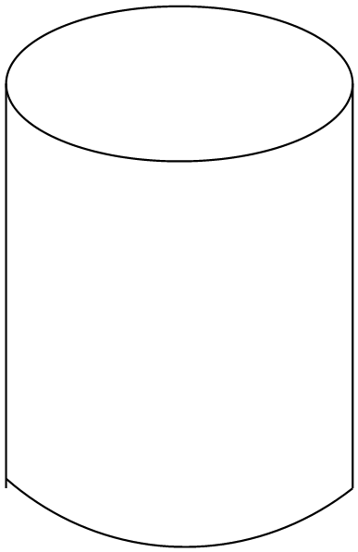

A) 157 cm2

B) 267 cm2

C) 377 cm2

D) 534 cm2

|  |  |
| --- | --- |
|  |  |

1. A funnel is a cone with no top. The funnel shown has a diameter of 2 inches and a slant height of 3 inches. What is the outer surface area of the funnel, to the nearest one decimal?

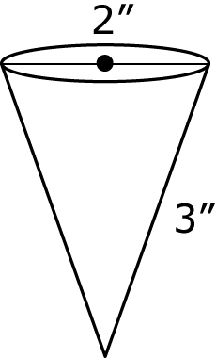

A) 9.4 in2

B) 12.6 in2

C) 18.9 in2

D) 31.4 in2

1. 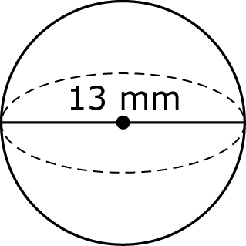What is the total surface area of the sphere shown?
2. 133 mm2
3. 163 mm2

1. 531 mm2

D) 2124 mm2

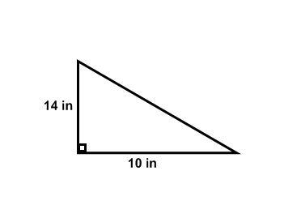

10. What is the area of the triangle shown?

A) 1.4 in2

B) 70 in2

C) 120 in2

D) 140 in2

11. What is the area of the circle shown to the nearest unit?

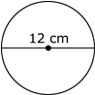 A) 38 cm2

B) 113 cm2

C) 226 cm2

D) 452 cm2



12. How many square feet is a 36″ by 36″ square tile?

A) 3

B) 6

C) 9

1. 12

13. Which list is in order from longest to shortest?

A) 1 cm, 1 m, 1 mm, 1 km

B) 1 km, 1 cm, 1 m, 1 mm

C) 1 km, 1 m, 1 cm, 1 mm

1. 1 mm, 1 cm, 1 m, 1 km

14. Which item would you use square meters to measure its area?

1. the bottom of your shoe
2. the classroom wall
3. the cover of your book
4. the screen of your cell phone

 15. What is the area of the curved surface of this cylindrical tube?

.

A) 157 m2

B) 226 m2

C) 305 m2

D) 452 m2

16. Michael got a toy race car for his birthday It came in a box shaped like a triangular prism. The box had a length of 20 cm. The base is an equilateral triangle with sides measuring 4 cm. The height of the equilateral triangle is 3.5cm. How much wrapping paper was needed to wrap the gift?



A) 94 cm2

B) 247 cm2

C) 254 cm2

D) 280 cm2

17. The scale for this collectible toy car is 1:60. What is the length of the actual car if the length of the scale model is 6 cm?



A) 12 cm

B) 36 cm

C) 128 cm

D) 360 cm

18. You want to produce a scale drawing of your classroom, which is 20 ft by 30 ft.

If you use a scale of 1:20, what will be the dimensions of your scale drawing?

A) 10 in by 15 in

B) 10 in by 30 in

C) 12 in by 15 in

D) 12 in by 18 in

19. What is the length of side A?

 A) 5 m

B) 7 m

C) 17 m

1. 19 m

For the next two questions, refer to the diagram shown.

1. 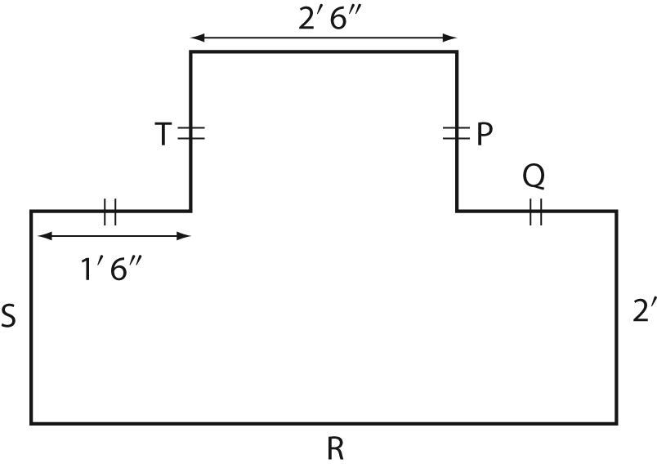What is the length of the side ‘T’ ?
   1. 1’ 6”
   2. 2’ 6”
   3. 3’ 0”
   4. 4’ 6”
2. What is the length of the side ‘R’ ?
   1. 3’ 6”
   2. 4’ 6”
   3. 5’ 6”
   4. 6’ 6”
3. You have floor tiles that are 1 m by 1 m. How many tiles do you need to cover the floor of the room if one square on the diagram represents 2 m.
   1. 60 tiles

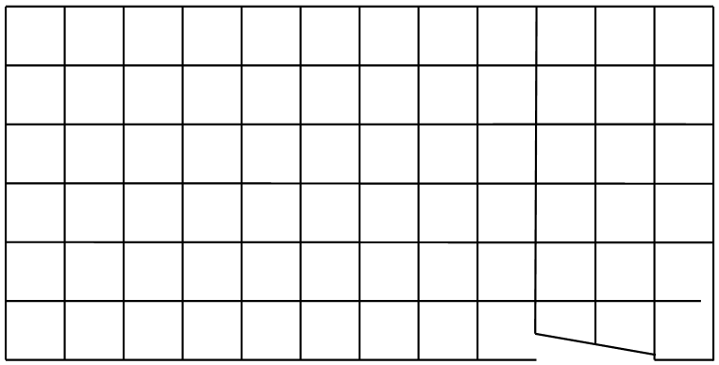

* 1. 72 tiles
  2. 144 tiles
  3. 180 tiles

1. 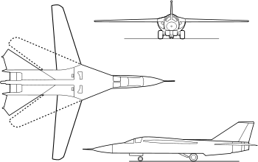Here are some base diagrams of a jet. What type of drawings are these?
   1. Exploded view diagram
   2. Isometric drawing
   3. One-point perspective drawing
   4. Orthographic drawing
2. 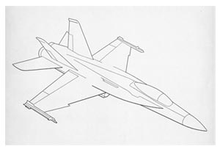A similar jet is now drawn using a different style. What type of drawing is this diagram?
   1. Exploded view diagram
   2. Isometric drawing
   3. One-point perspective drawing
   4. Orthographic drawing
3. 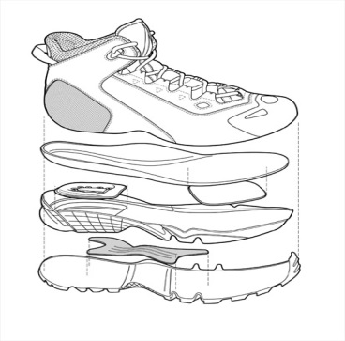What type of drawing method was used to create this diagram?
   1. Exploded view diagram
   2. Isometric drawing
   3. One-point perspective drawing
   4. Orthographic drawing
4. 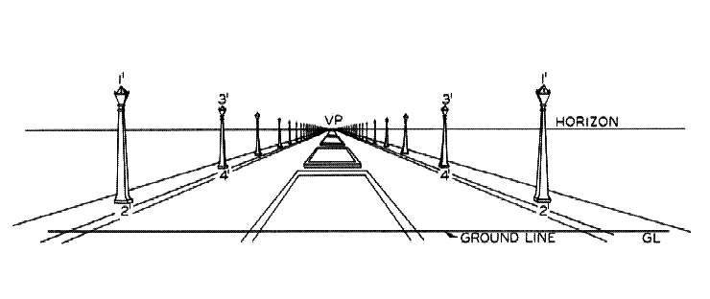 The artist is using which type of drawing in this sketch?
   1. Exploded view diagram
   2. Isometric drawing
   3. One-point perspective drawing
   4. Orthographic drawing

27. Two towns that are 24 km (1 km= 100 000 cm) apart are 8 cm apart on a map. What is the scale of the map?

A) 1:250 000

B) 1:300 000

C) 1:392 000

D) 1:400 000

28. A room measures 16 feet by 9 feet with a door that has a width of 4 feet. How much baseboard is needed to go around the room?

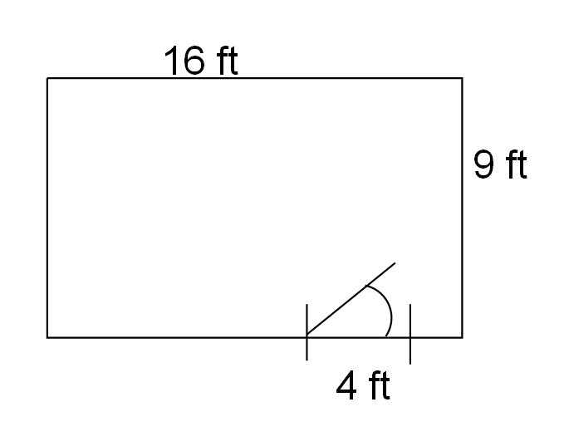

A) 21 ft

B) 46 ft

C) 50 ft

D) 144 ft

 29. This object is made using 4 linking cubes. Which sketch is the right side view of the object?

|  |  |
| --- | --- |
| A) |  |
| B) |  |
| C) |  |
| D) |  |

30. Jake created a three dimensional object using blocks. Which is the **only** correct view of his object? 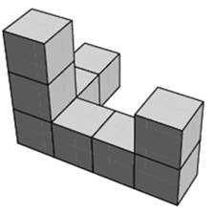

Front

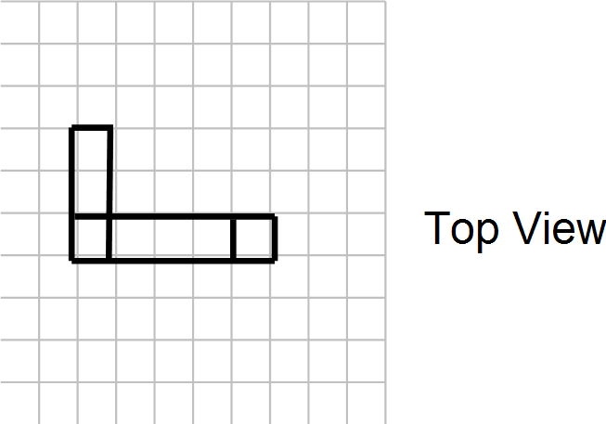

A)

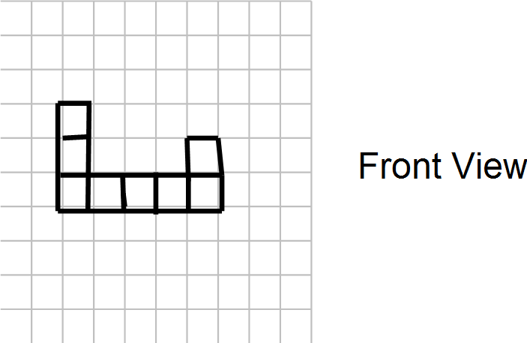

B)

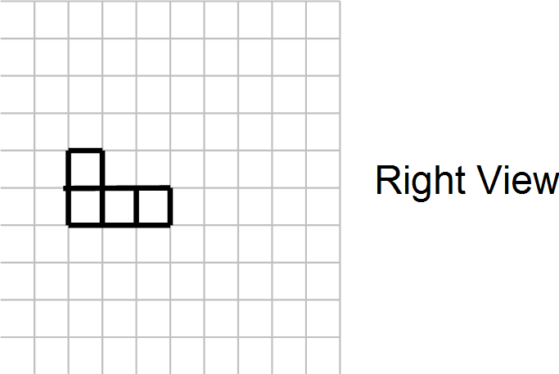

C)

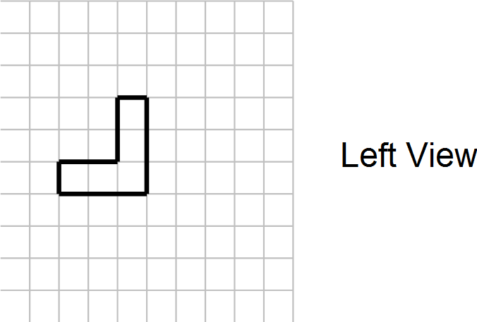

D)

**Part II – Constructed Response :**

Answer each of the following in the space provided. Show all workings to ensure full marks.

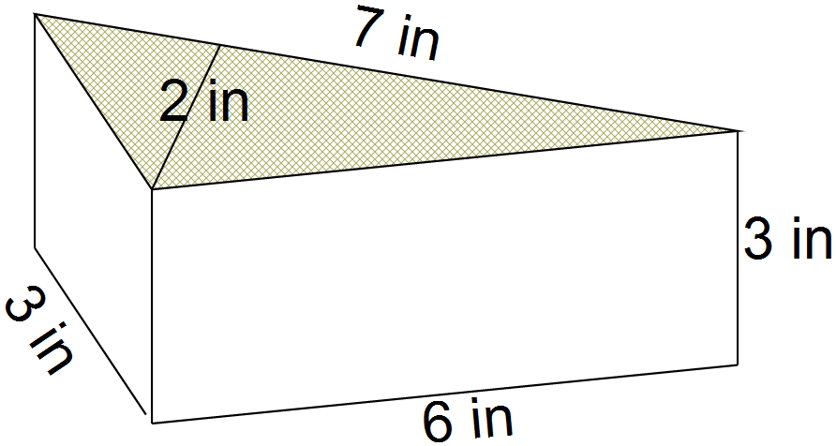

31. Consider the following triangular prism:

A) **Sketch a net** of the prism. (1 mark)

1. Calculate the **surface area** of the triangular prism. (2 marks)
2. Calculate the **volume** of the triangular prism. (2 marks)

32. **Sketch and label** a net of a square based pyramid, which has a base length of 5 feet, and stands 9 feet **tall** (not slant height). (1 marks)

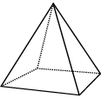

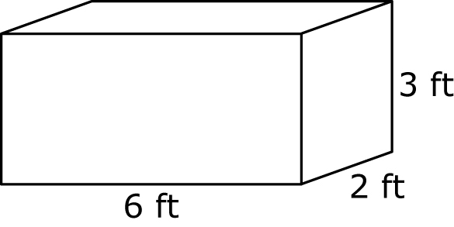

33. Using the appropriate formulas

A) calculate the **surface area** of the rectangular prism. (2 marks)

B) Calculate the **volume** of the rectangular prism (2 marks)

34. The container for Pringles chips is in the shape of a cylinder.

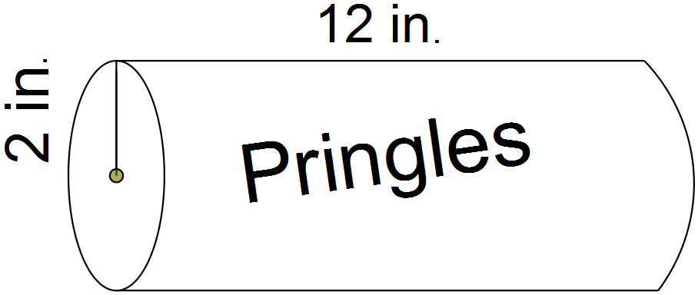

1. Calculate the **Surface Area** of the container to find out how much material is needed to make the container, not including the plastic lid for one end. (2 marks)
2. Calculate the **Volume** of the container to see how much will fit inside. (2 marks)

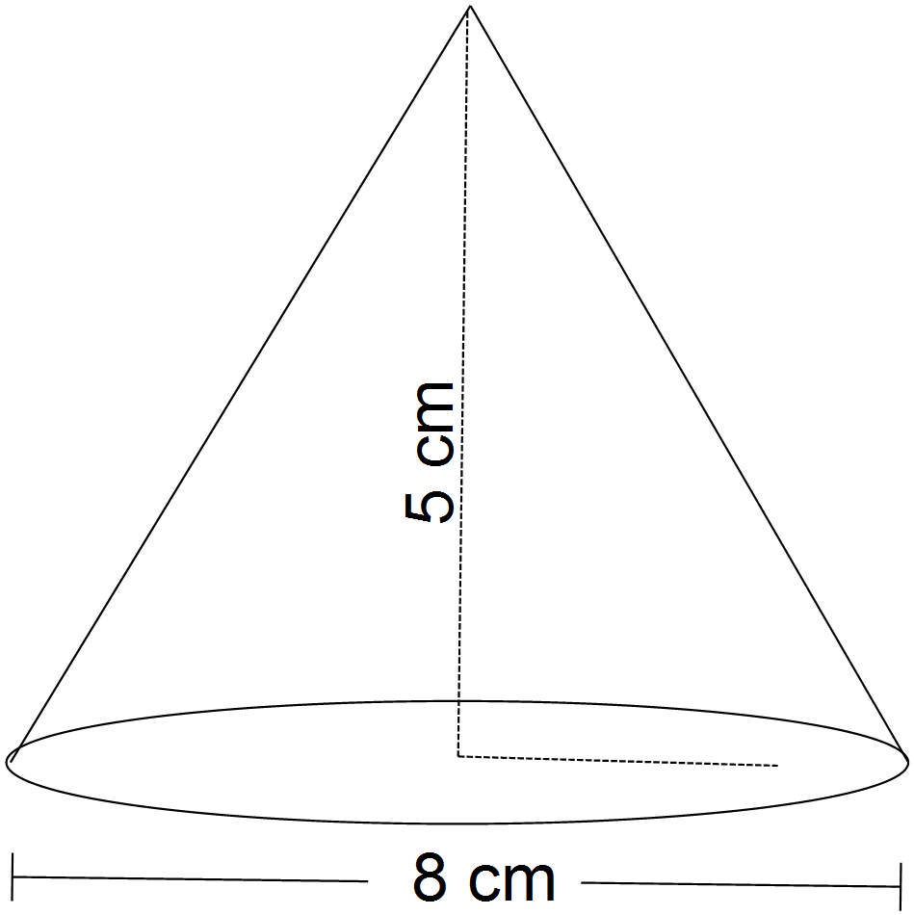

36. Consider the following cone and answer the following questions. Round all answers to the nearest tenth of a unit.

A) Calculate the **slant height** of the cone using a2 + b2 = c2. (2 marks)

1. Calculate the total surface area for the cone. (2 marks)
2. Calculate the total volume of the cone. (2 marks)

37. The diagram shows part of the floor plan of a house.

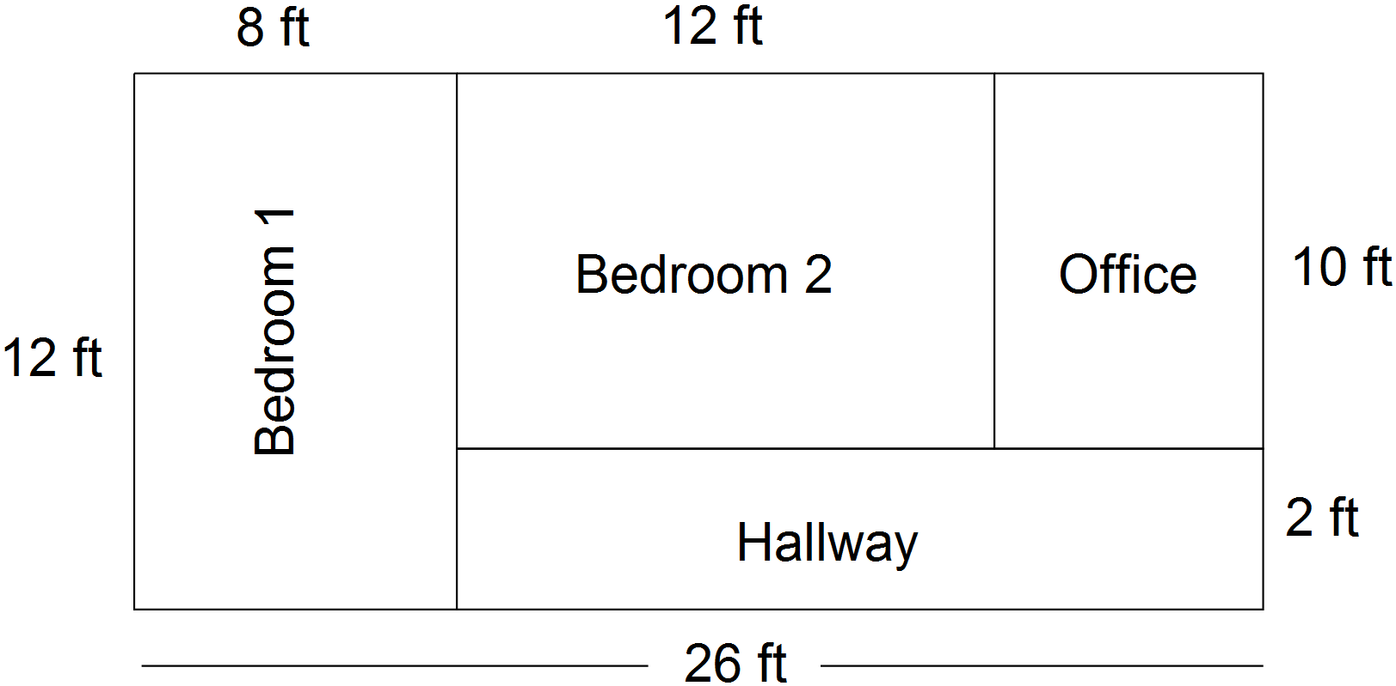

1. As seen on the diagram above, the length of bedroom 1 is 12 ft. On a scale diagram, this room is 6 inches long. What is the scale factor of the diagram? (1 mark)
2. Using the same scale factor, what is the **length** of the hall way on the scale diagram? (1 mark)
3. What is the total **area of** the home office in the real house? (1 mark)
4. What is the total perimeter of the house shown in the scale diagram? (1 mark)

38. What are the missing measurements of the figure shown? (2 marks )

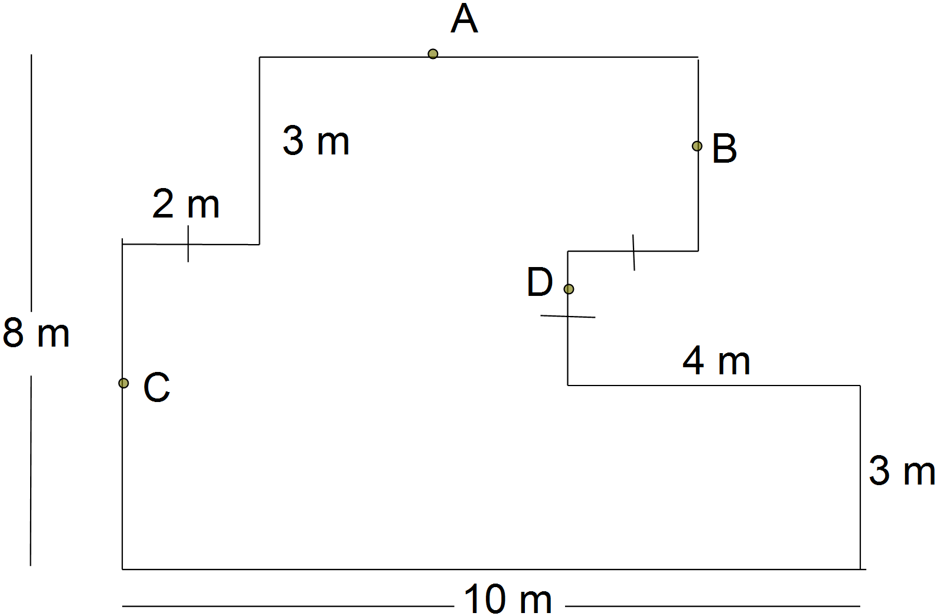

A _________

B _________

C _________

D _________

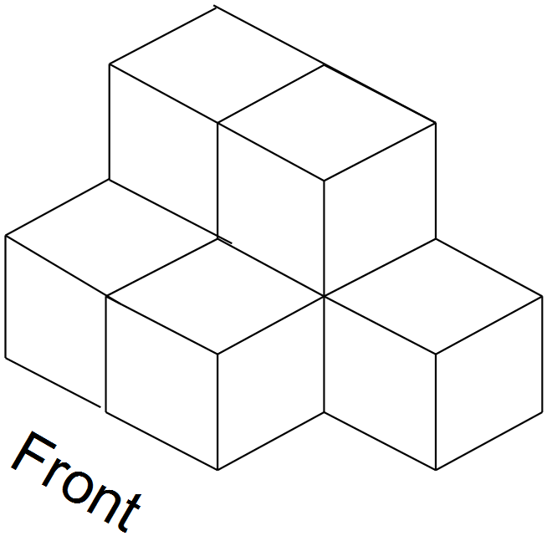

39. Sketch and label the front, top, left side and

right side views of the object shown.

(2 marks )

**Front (1 mark) Top (1 mark)**



**Right (1 mark) Left (1 mark)**

37. Use the one point perspective technique to create a row of pentagon shapes in 3D. Label the type of vanishing point that you use. (2 marks)

**Math 2202**

**Answer Sheet - Part I Name : ________________________**

**Directions:** Place answers for part I in the space provided.