Chapter 9 Meal Plan Management
Name: _______________________________________________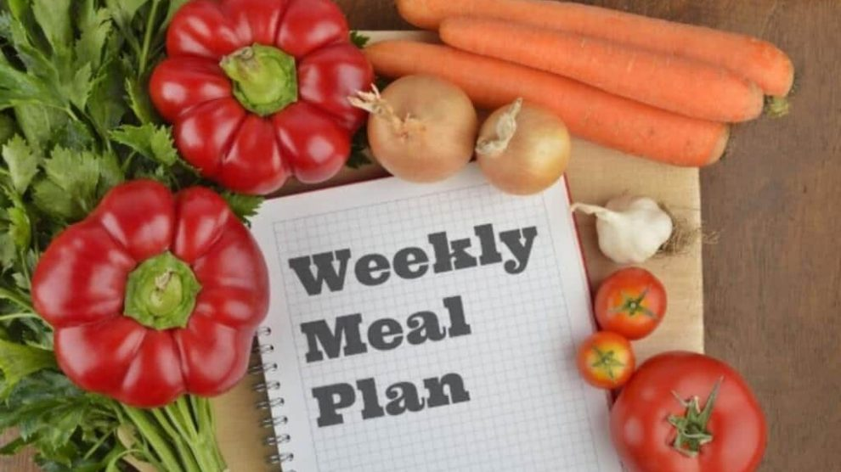
Read pages 157 - 187 and answer the following questions

1. Making a meal plan must consider the people that you are planning for. What things must you find out about the group you are planning meals for?
____________________________________________________________ ________________________________________________________________________________________________________________________

2. (160) People can have special circumstances that mean they change their diets. List some reasons for special diet plans and give examples of how it would change how they eat.
____________________________________________________________ ________________________________________________________________________________________________________________________

3. (163) There are a lot of aspects to food choices in a diet. Explain how the five listed on this page must be considered before making an effective meal plan.
____________________________________________________________ ________________________________________________________________________________________________________________________
4. What is a budget? How would it benefit someone to develop and follow a budgeting plan before planning meals and shopping?
____________________________________________________________ ________________________________________________________________________________________________________________________
____________________________________________________________

5. (167) One of the big conditions for a meal plan is the cost. Describe some ways that you can save money as you plan your meal.
____________________________________________________________ ________________________________________________________________________________________________________________________
____________________________________________________________

6. We will be developing an individual meal plan very soon. Come up with a list of meal options that you would like, divided into Breakfast, Lunch and Supper choices.
Breakfasts
________________________________________________________________________________________________________________________
____________________________________________________________

Lunches
________________________________________________________________________________________________________________________
____________________________________________________________

Suppers
________________________________________________________________________________________________________________________
____________________________________________________________

