Volumes of 3D Shapes
Name: |  |  | Math 2202
Results: | /50 = % |  |  | Instructor: Mr. Gillett
Answer all questions in the space provided. Show workings where possible to get full marks.
- Which of the following is not a 3 dimensional figure? 24 marks
  - Cone
  - Cylinder
  - Prism
  - Rectangle

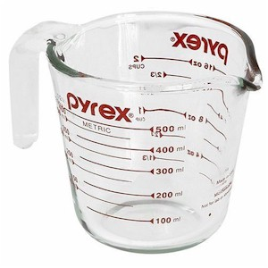
- A recipe for pancakes calls for ¼ cup of melted butter. How many fluid ounces would that be?
  - 1 fluid ounce
  - 2 fluid ounces
  - 4 fluid ounces
  - 8 fluid ounces

- Which object would you estimate has a 1 gallon capacity?
  - bathtub
  - drinking glass
  - small gas can
  - tea pot

- Which of the imperial units would be equal to 1 pint?
  - 8 fluid ounces
  - 1 cup
  - 2 cups
  - 1 quart
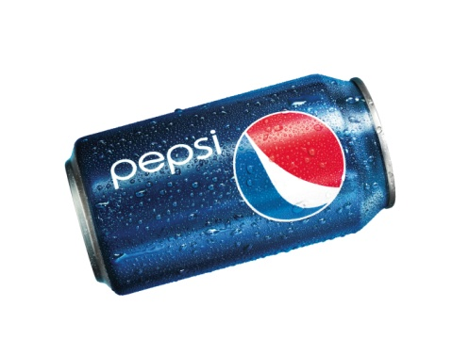
- What is the capacity of a can of pop?
  - The same as its volume
  - Greater than its volume
  - Less than its volume
  - It depends on how full it is
- How many cones could be made with the material of the cylinder with the same sized base and height?
  - 1
  - 2
  - 3
  - 4
- Which list of units is in the correct order from smallest to largest?
  - Pint, cup, litre, gallon.
  - Ounce, cup, pint, gallon
  - Gallon, quart, pint, cup
  - Ounce, pint, cup, litre
- 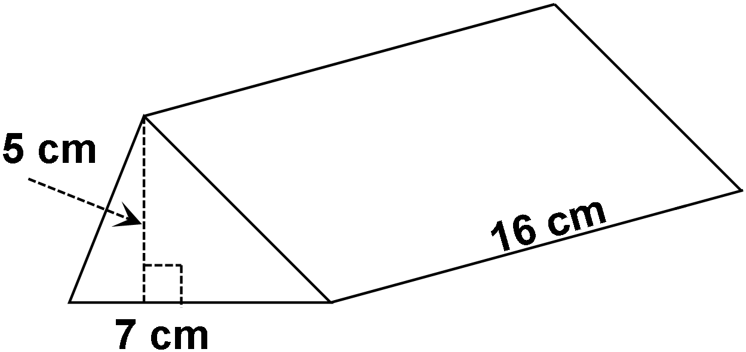What is the volume of the shape shown here?
  - 140 cm³
  - 192 cm³
  - 280 cm³
  - 560 cm³
- A steel oil drum is 35 inches tall and has a diameter of 24 inches. What is the approximate capacity of the drum?
  - 452 in³
  - 15800 in³
  - 49740 in³
  - 63330 in³
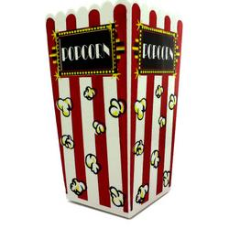
- The popcorn container shown has a square base that is 10 cm wide, and is 22 cm tall. Approximately how much popcorn could be put into the container?
  - 120 cm³
  - 230 cm³
  - 2300 cm³
  - 4900 cm³
- A drink container says it holds 1000 ml. Which imperial measurement would be an easier way of describing this container?
  - 1 cup
  - 1 gallon
  - 1 pint
  - 1 quart
- Which shape would be a good example of a composite 3D figure?
  - A computer tower
  - A coke bottle
  - A math textbook
  - A soup can

- Calculate the volume of each of the following 3D figures. Show your workings 9 marks
  - 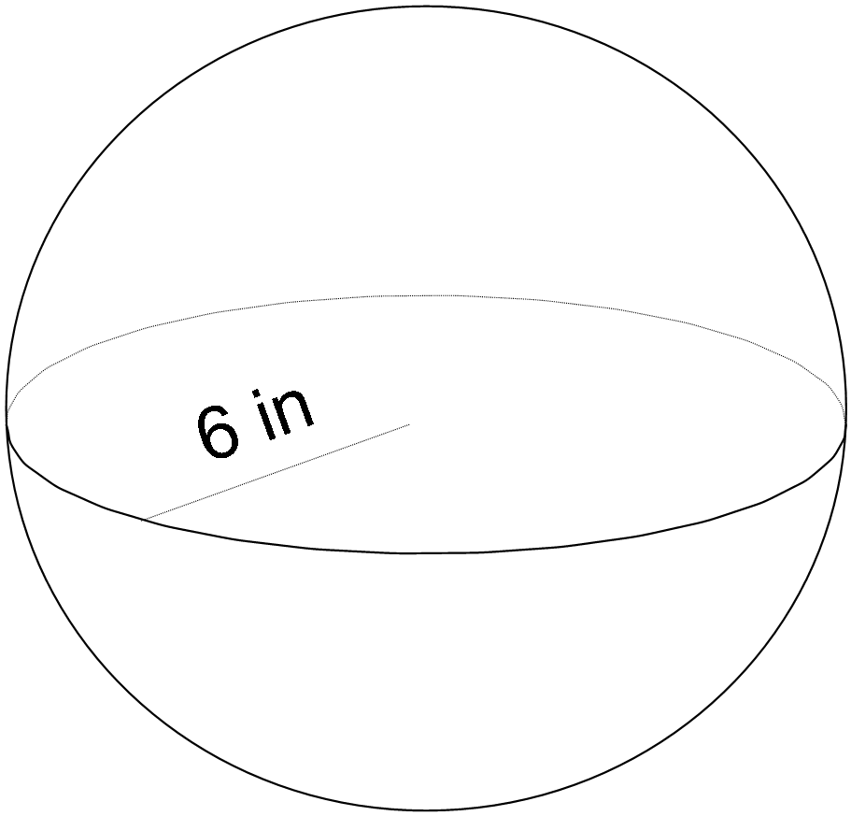

  - 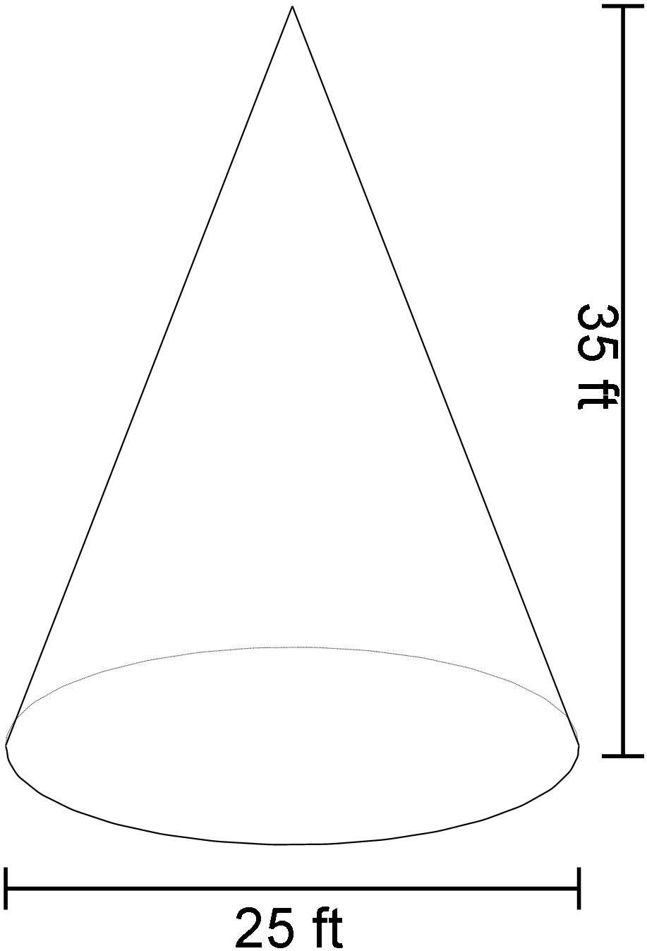

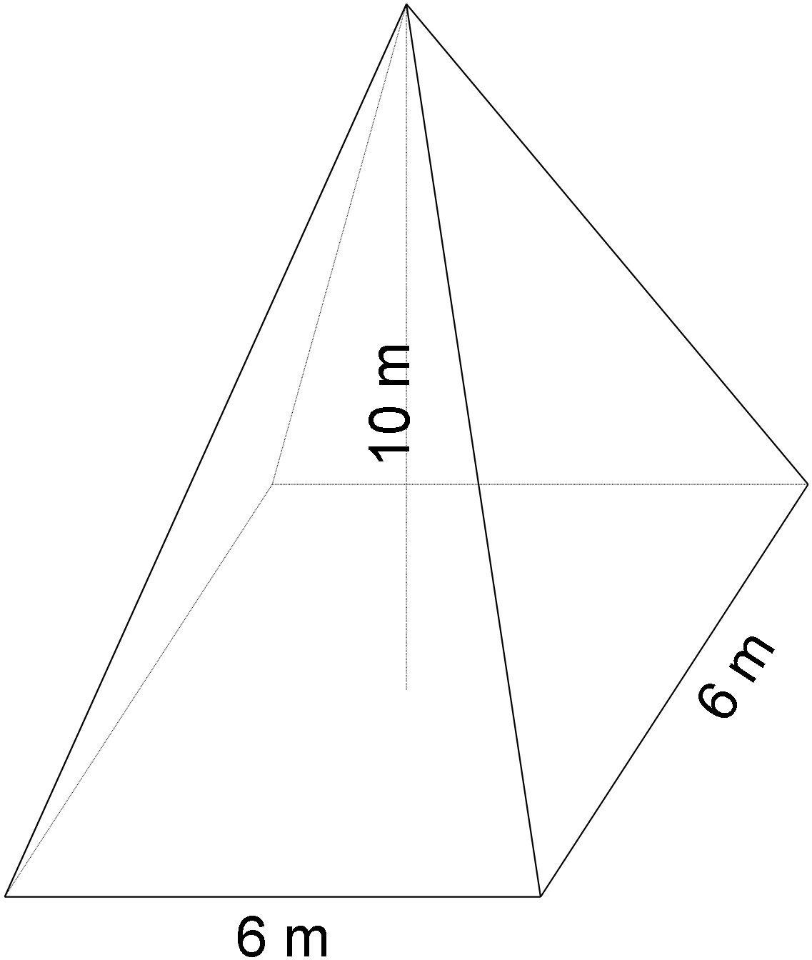

- Answer the questions about the Composite Figures shown? Show all Workings. 8 marks
  - How much space is in the Security Camera Housing
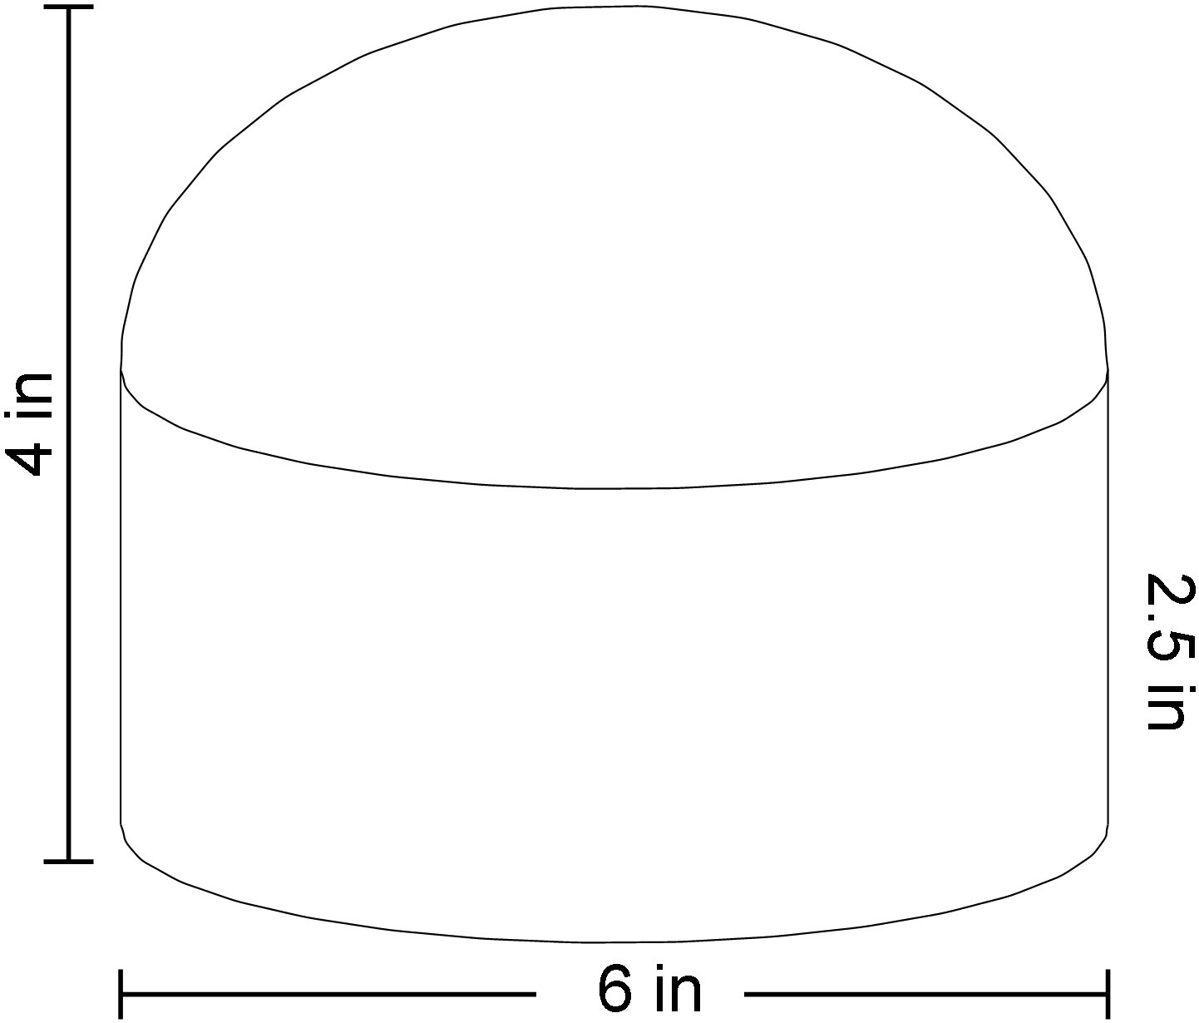

  - How much material is needed to make the Coupler for a PVC pipe
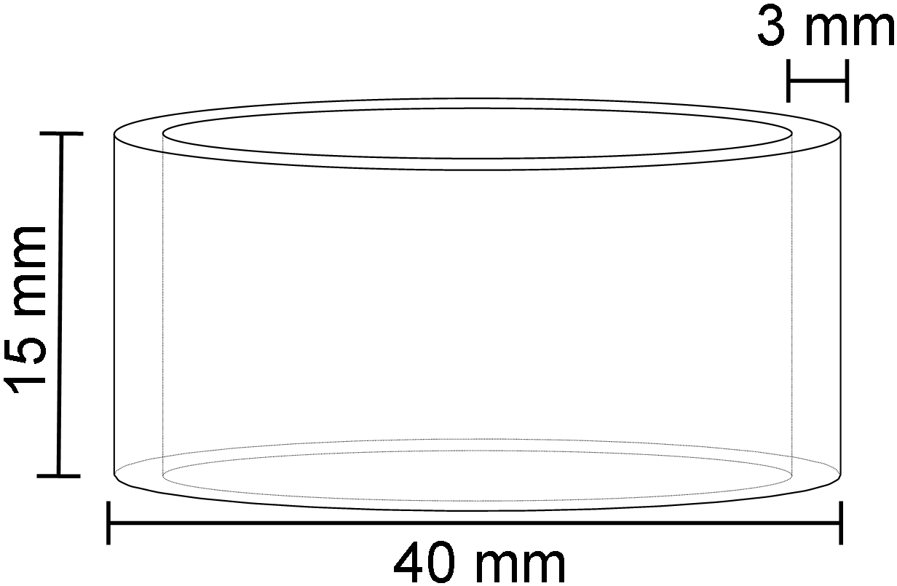

- The bathroom at the O’Brien Centre is an L-shaped room with a 10 foot ceiling. 5 marks
  - 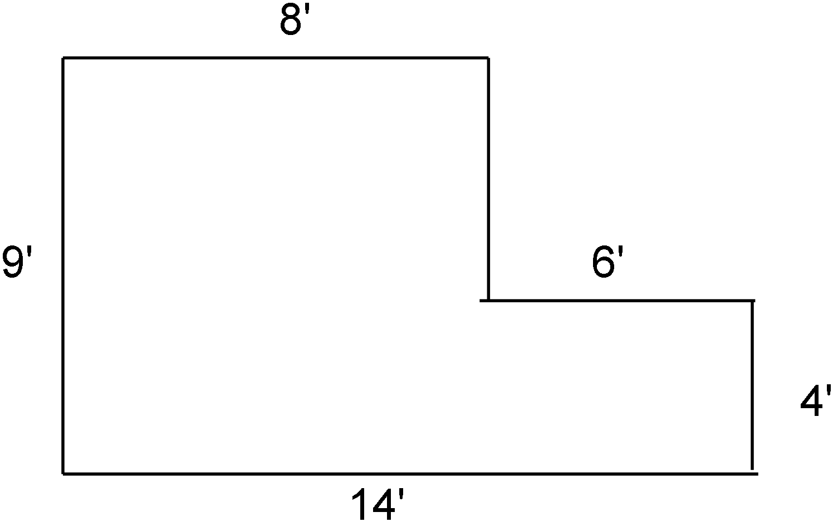Given the floor diagram shown, what is the total capacity for air of the room?

  - If the vent fans can draw out 100 ft³/min, you long would they take to exchange all the air in the bathroom?

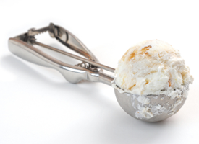
- A scoop of ice cream has a diameter of 2.5 inches. 4 marks
  - What is the approximate volume of ice cream
used in a double scoop cone serving?

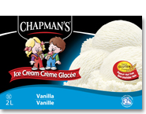
  - How many of these cones can you get from a 200 in³ box of Chapman’s ice cream?

