# Graphing

|  |  |  |  |  |
| --- | --- | --- | --- | --- |
| Name: |  |  | Math 2202 | |
| Results: | /32 = % |  |  | Instructor: Mr. Gillett |

Answer all questions in the space provided. Show workings where possible to get full marks.

1. Which type of graph would best be used to show the population growth of Happy Valley – Goose Bay over the last 10 years?

12 marks

* 1. A Bar Graph
  2. A Circle Graph
  3. A Line Graph
  4. A Scatterplot

1. The Graduating class voted on which colours they wanted for their prom. What type of graph would best show the different colours the students chose?
   1. A Bar Graph
   2. A Circle Graph
   3. A Line Graph
   4. A Scatterplot
2. 150 people were surveyed about their favorite soft drinks. According to the percents on the graph, how many people would you expect to drink Coke?



* 1. 40
  2. 60
  3. 110
  4. 75

1. Which sport in the graph shown has the most participants?
   1. basketball
   2. hockey
   3. softball
   4. swimming
2. What is the word used to describe the total number of people in each group?
   1. Census
   2. Frequency
   3. Quantity
   4. Totality
3. 26 of 128 Mealy Mountain’s Grade 11 students are in Ms. Giles homeroom. What percent of the students are in this class?
   1. 20 %
   2. 26 %
   3. 28 %
   4. 49 %
4. 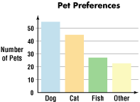The bar graph below shows the number of people in Lisa’s class with their pet preferences. What conclusion can be made from the graph?
   1. Dogs are the best pet in the world
   2. About 40 people in Lisa’s class prefer fish
   3. More people in Lisa’s class prefer cats to fish
   4. More people in Lisa’s class prefer cats to dogs
5. Choose the best scale for a frequency table for the following set of data. 12. 19. 28. 12. 19. 3. 2. 7. 7. 9. 15. 3. 1. 26
   1. 0 *– 10*
   2. *10 – 20*
   3. *0 – 20*
   4. *0 – 30*
6. 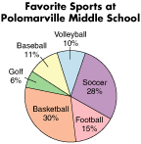According to the circle graph shown, which of the following statements is ***false***?
   1. More people choose football than baseball
   2. Soccer was the most favorite sport
   3. 10 percent of students said volleyball was their favorite sport
   4. The most popular sport was basketball
7. A group of students were asked if they prefer vanilla, strawberry or chocolate ice cream. A frequency table shows that 53 of the students surveyed prefer vanilla, 29 prefer strawberry, and 18 prefer chocolate. If they all responded, how many students were surveyed?
   1. 47
   2. 53
   3. 82
   4. 100
8. Which of the following could be used to make predictions about future events by looking for patterns?
   1. Circle graphs
   2. Frequency tables
   3. Intervals
   4. Line graphs
9. 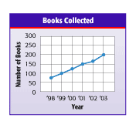The graph shows the number of books that were donated each year for a used book sale. What does the graph tell you about the number of books donated?
   1. There is an increase in the number of books donated each year
   2. The number of people donating books is increasing each year
   3. The number of books donated each year is decreasing
   4. Twice as many books were donated in 2008 than in 2003
10. The data below show the average rent for an apartment in various cities across Canada. Draw a bar graph to represent the data.

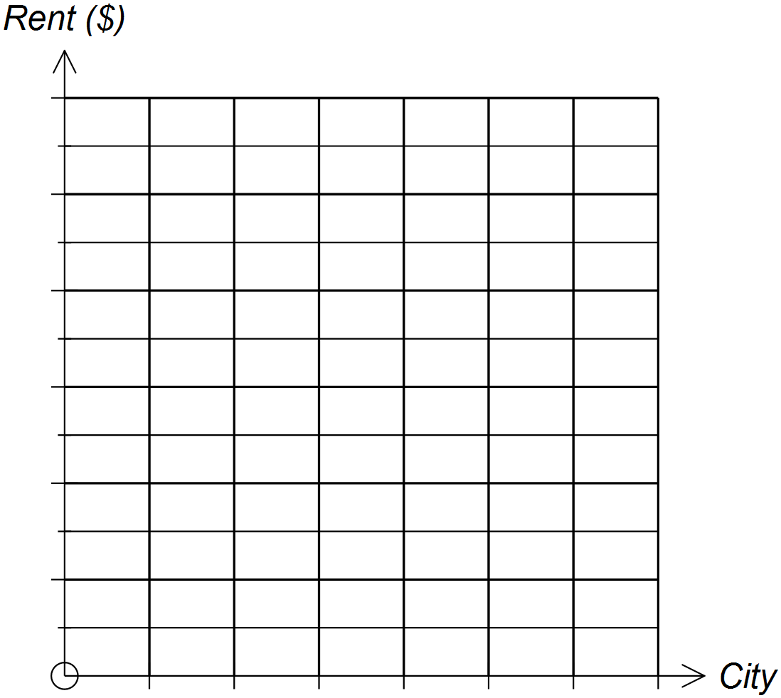

3 marks

|  |  |
| --- | --- |
| City | Monthly Rent ($) |
| Edmonton, AB | 1200 |
| Fredericton, NB | 800 |
| Montreal, QC | 1300 |
| St. John’s, NL | 700 |
| Vancouver, BC | 1800 |
| Winnipeg, MB | 900 |

1. 1. A hot dog with a mass of 50 g has the following nutritional content:

5 marks

Moisture 29 g Protein 7 g Fat 10 g

Carbohydrate 1 g Other 3 g

Complete the table and display the information in a circle graph.

|  |  |  |  |
| --- | --- | --- | --- |
| **Component** | **Amount**  **(g)** | **Percent**  **(g / total)** | **Degree**  **(% * 360)** |
| Moisture |  |  |  |
| Protein |  |  |  |
| Fat |  |  |  |
| Carbohydrate |  |  |  |
| Other |  |  |  |
| **Total** |  |  |  |

1. The table shows the sales of two smart phone apps for a period of six months.

8 marks

* 1. Which type of graph would be best to compare the sales of the apps? Draw this graph.

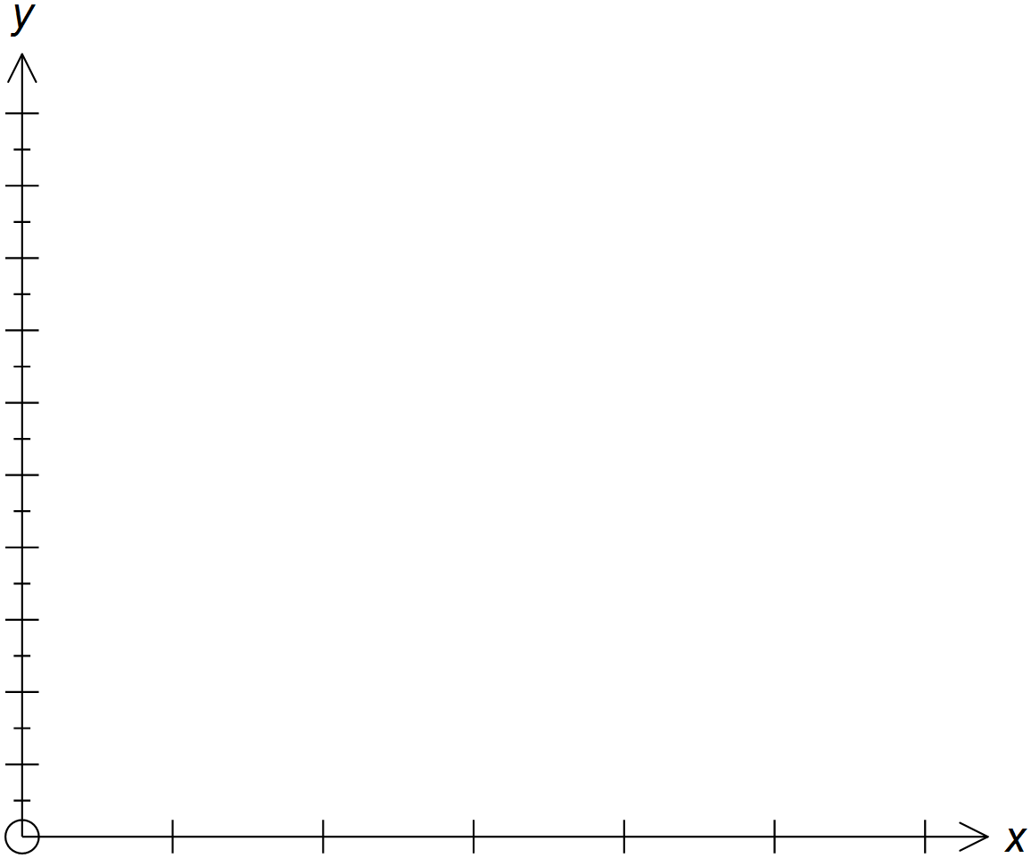

|  |  |  |
| --- | --- | --- |
| Month | App. A | App. B |
| March | $118 000 | $122 000 |
| April | $117 000 | $124 000 |
| May | $121 000 | $124 000 |
| June | $119 000 | $126 000 |
| July | $124 000 | $127 000 |
| August | $127 000 | $128 000 |

* 1. Draw a second graph that makes App.A’s sales in August appear to be much greater than App.B’s August sales.



* 1. Explain how could you change the graph so that App. B’s sales appear to be increasing faster than App. A’s.

1. A company’s profits over the past three years are shown below.

4 marks

2010 --- $200,000

2011 --- $230,000

2012 --- $250,000

* 1. Construct a graph, from the worker’s point of view to show that the company has been getting large growth in profits so they can afford to given them a raise

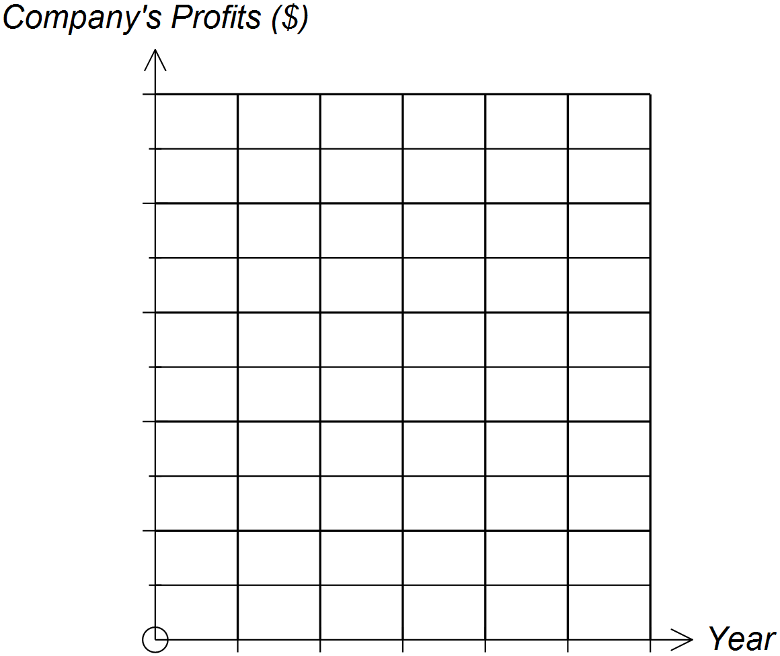

WORKERS

(Want a Raise)

* 1. Create another graph, from the company’s point of view that shows very little growth in profits, showing that they can’t afford to give any raises.



COMPANY

(Don’t want to

give raises)