7.1 Return to Peace Time
Canada was in a unique position after the Second World War compared to the rest of the western world. Even with the $10 billion war debt the country was still in good economic position;
- We had no destroyed infrastructure (roads, utilities, water lines etc) to rebuild because of the war
- We had a modern and well developed manufacturing sector and a well trained work force, from supplying goods for the war effort. This was easily converted to produce goods needed during the new peace era.
- Canada’s GNP had doubled during the war. The manufacturing section was creating a well paid work force. This meant people had more money saved and more taxes were being paid to the government.
- The Canadian Government was able to give money to help reconstruction in the European countries destroyed during the war. This money could then be used by countries like Britain, France and Germany to buy Canadian goods.
- The government was able to properly welcome their veterans back into society. They helped with finding jobs, were given grants for training in university or trades, they were given grants for starting farms or fishing ventures, and they were provided with low cost land to buy or build their own homes.
- Because of this state of prosperity and the number of returning soldiers, there was a major rise in marriages and babies born during these years. Anyone born in the years from 1946 to 1960 is considered to be part of the ‘baby-boomer’ generation. The population of Canada grew from 12,000,000 to 18,000,000 in these years, due to births and immigration. (The baby boomers are now in the process of retiring, creating a very large body of senior citizens in Canada.)
- The Canadian government had the resources to put social programs in place that supported the working classes.
  - In 1940, Unemployment Insurance was introduced country wide
  - In 1945, Family allowance payments gave mothers a payment of $5 - $8 a month for each child from ages 0 – 15. This could add up to ½ as much as the family earned from their regular income per month.

7.2 Immigration and Urbanization
During the post war period immigration in Canada changed greatly. The government realized that they needed an increased population to build our country’s manufacturing sector without draining people away from our primary industries. We couldn’t do both with the population that Canada had without new growth so they actively welcomed immigration. King’s government actively targeted people for immigration. At first there was preference given only to British, American and then French citizens, but then openings were made for other groups.
- We welcomed in thousands of European Displaced Peoples – those made homeless during the war who wanted to make a fresh start rather than rebuild, or those who were fleeing the invasion of the Soviets when Russia took over most of Eastern Europe; countries like Poland, Estonia, Latvia, Finland and Lithuania.
  - Example: The Walnut came to Sydney from Sweden in December 1948 with 348 people crammed on a ship designed to carry cargo and 14 crew.
- King repealed the 1920’s Chinese Immigration Act so that wives and Children of immigrant Chinese and East Indian men were no longer refused entry. This meant that more families would move permanently to Canada rather than having men come for work and then return home.
- In 1948 Louis St. Laurent, who took over the Liberal Party from King, continued the push for immigration and set up the Department of Citizenship and Immigration to carefully monitor which groups came into Canada.
- By 1962 our immigration laws allowed entry based on people’s skills and training rather than their ethnicity.

- Unlike past waves of immigrants who were encouraged to move west and set up farms, the bulk of these immigrants joined the growing urban population in Canada. Canada was becoming heavily urbanized and there was the creation of a new phenomenon…. The Suburb. These communities were built just outside the major cities that give people a small town feel with community schools and housing, but still have access to the jobs and opportunities of the big city.

7.3 The Post War Boom
As stated earlier, the years following the Second World War were great times for Canadian business because of our existing infrastructure, available workforce and the abundance of raw materials. While other countries struggled to rebuild the foundations of their economies, Canada went into a Boom.
- There was an increase in farming, fishing and lumber harvesting all across Canada
- Exploration into new mining and mineral sites led to openings throughout the Canadian Shield – the zone of thin soil covered bedrock which makes up most of Canada’s Boreal forest and northern regions.
  - Nickel @ Timmons, Ont
  - Nickel @ Sudbury, Ont
  - Iron Ore @ Labrador City, NF
  - Uranium @ Uranium City, SK
  - Oil @ Athabasca tar sands, AB

- This was a time of ‘Megaprojects’ started by the Federal and Provincial governments across Canada. With the increase in taxes and the positive outlook, many governments felt that spending to build the economy was a safe bet.
  - The Trans-Canada Highway (1949 – 1972)
Created a nation wide system for transport of goods and people from Vancouver to St. Johns.
  - The Trans Canada Pipeline
A pipeline that connected Alberta’s oilfields with the main markets in Ontario and Quebec
  - The Toronto Subway
Canada’s first underground subway system. Requiring massive tunnels to be dug underneath the existing sections of Toronto
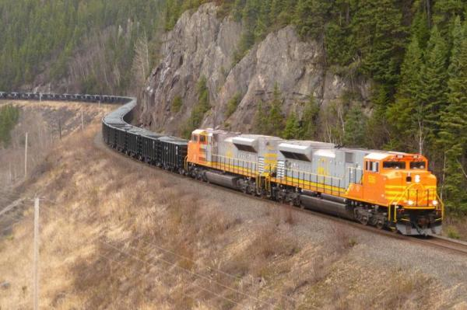
  - The Quebec North shore and Labrador Railway
A rail line that connected Sept-Iles Quebec on the St. Lawrence seaway with newly opened mines and hydro developments in Labrador and Northern Quebec (Shefferville)

  - Churchill Falls Hydro Development
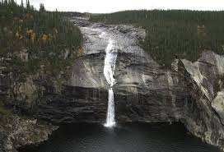
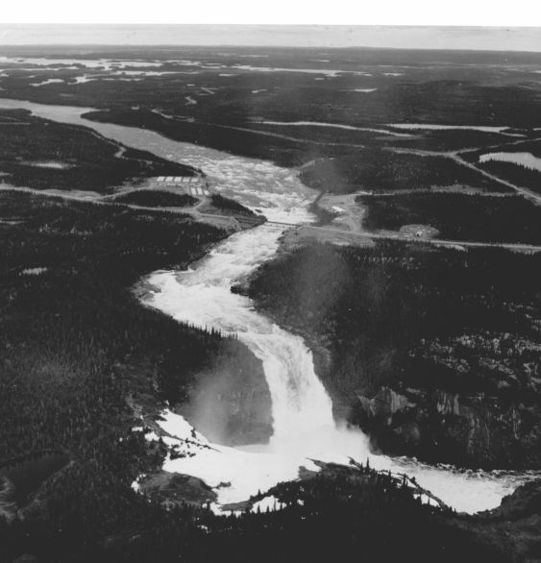
Massive Hydro-electric development in Central Labrador

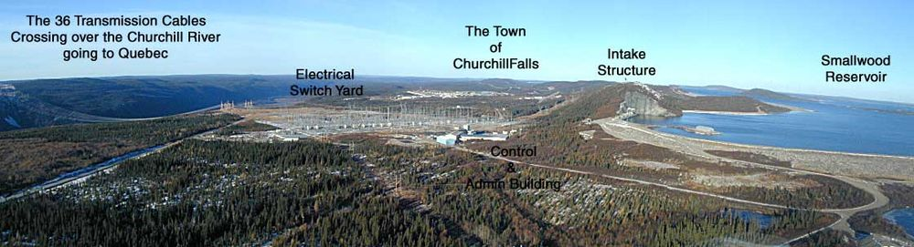
The Cold War
At the end of the Second World War we were left with only two countries in the world with substantial military power and technical superiority: The United States and Russia.
- The US was untouched in terms of its manufacturing and technical knowledge during the war, and their massive mobilization of people to the war effort had created a huge potential for development.

- Russia still had great numbers of people and it had virtually taken over all of Eastern Europe as part of the newly formed U.S.S.R. (Union of Soviet Socialist Republics). All of their countries wealth was under the control of the government under the Communist system, so it too was able to push forward in developing military technology.

- Given also that at the end of the war both the US and the Russia competed to find and occupy Nazi scientific outposts so that they could capture Nazi Scientists. Hitler had pushed for great scientific programs and had the most advanced leaders in many fields, including rocketry. The US and Russia wanted to use these scientists for their own programs. It was breakthroughs from Nazi Scientists that led to NASA’s space programs being successful and the progress of Nuclear missile programs.
The US. And Russia became the leaders in the opposing forces of Democracy and Communist, two drastically different ideological systems. Unlike a ‘Hot War’ with active aggression and fighting like WWII they entered a ‘Cold War’ where they worked against each other with propaganda, spying and political maneuvers.
The US and USSR became our world’s first ‘SuperPowers’; countries with the ability to destroy the planet many times over. This is due to their stockpiles of nuclear weaponry.
Canada was also involved with the Nuclear Age
- The AECL, the Atomic Energy of Canada Limited, was started 1952
- Canadian scientists developed the CANDU reactor, this became the safest nuclear reactor power generating plants running on natural uranium
  - Today there are 29 CANDU reactors in use around the world, and 13 "CANDU-derivatives" in India, developed from the CANDU design after India detonated a nuclear bomb in 1974 and Canada stopped nuclear dealings with India. The breakdown is:

    - Canada: 19 (+5 old)
    - South Korea: 4
    - China: 2
India: 2 (+13 CANDU-derivatives in use) Argentina: 1 (+1 planned)
Romania: 2 (+2 partly constructed)
Pakistan: 1

- During these years Canada started a program of Shared defense of the far north in partnership with the US
  - Pinetree network 1954.. more than half built by Americans
  - Mid-Canada Line - build by Canada
  - Distant Early Warning line 1957 – built mainly by the US. The DEW stations were run by Americans and the properties became American territory
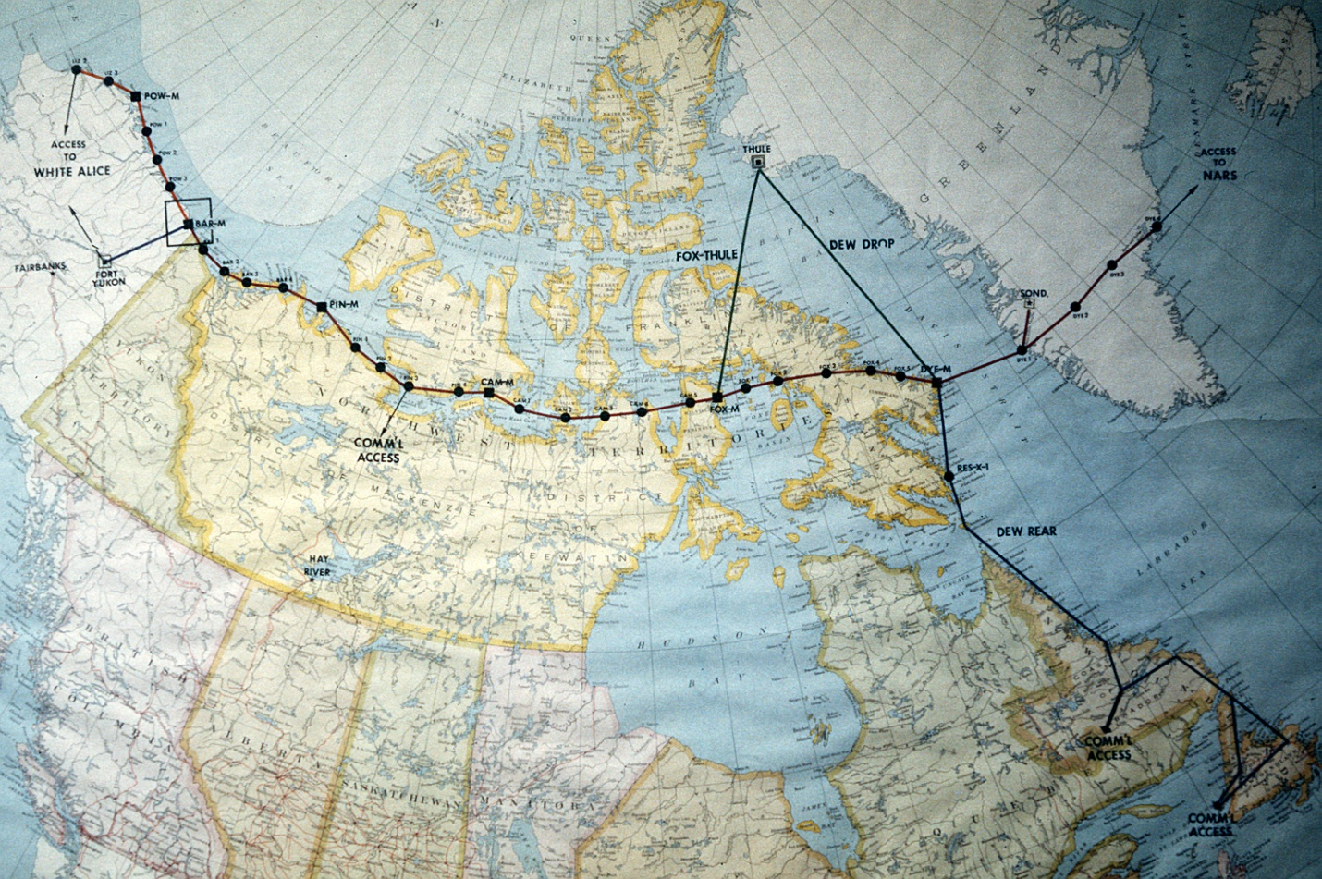

- Canada also had its share of military technology advancements. The most infamous being The Avro Arrow program.
  - During the 1950’s Avro Air spent 400 million developing jet fighter technology. The Arrow was its best creation, a world class jet fighter that was designed to protect the north again Soviet threats. The program was cancelled by PM Diefenbaker in 1958 after they agreed to buy American made jets. After the Arrow’s demise many of Canada’s aeronautical leaders moved south and took jobs with Avro’s competitors.

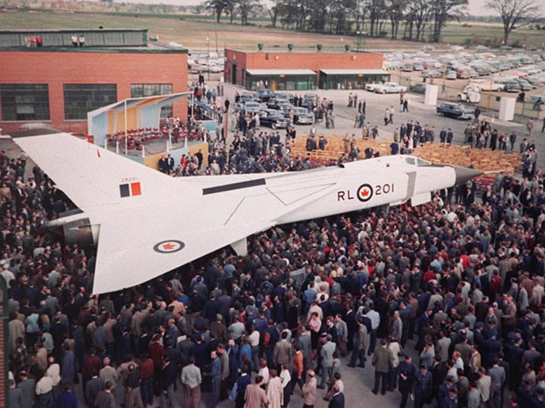

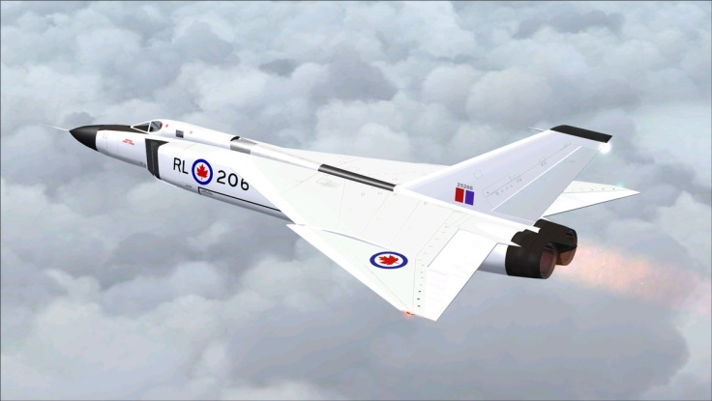
Note: Using the original designs from the 1950’s, a group of aeronautical developers in 2012 proposed remaking the Avro Arrow as a modern fighter for the Canadian Air Force.

7.4 Economic Problems
By the time 10 years had passed from the Second World War, the rest of the world was well into recovery and building their own economies. Canada, who had benefitted so much from foreign trade, began having some economic problems:
- 1956 – the European Common Market (ECM) was created as a union including most European nations. They realized that they had to work together more for their joint interests and soon started raising tariffs against Canadian goods.

- American surpluses in wheat growth meant that Canadian farmers had a harder time finding markets to sell their grains.

- The Bank of Canada decided that they should increase interest rates to attract investment in Canada. This meant that we would also pay higher interest rates for mortgages and personal loans.

- The biggest problem was the balance of trade issues. Canadians had been making good wages for years and were interested in buying foreign goods; cars, clothing, etc. We were buying more from outside Canada than we well exporting. This meant we were losing more money than we were taking in.

- There were concerns in Canada over the growing amount of American Investment and ownership of Canadian companies. Many of our businesses are actually branch plants of larger American companies. The worry is that this means we are not in control of our own economy. As we saw during the economic downturn in 2008-2009 the parent company in the States isn’t worried about shutting down a Canadian plant in order to save their overall corporation. This still means the loss of many Canadian jobs.

- During the 50’s, 60’s and 70’s many farmers left the land and took jobs in the cities. This meant that family farms were either shut down or bought out by larger commercial farms. Smaller farms really struggled to survive against large operations with better equipment.

- Atlantic farmers also had problems competing against large foreign trawlers. The government increased the area under Canadian control to the 12 mile limit in 1964 but it was still impossible to control the problem which eventually led to closing the cod fishery.

7.5 Growth of the Nation
- PM Louis St. Laurent believed in helping the nation grown after the war. One of his goals was to have Newfoundland join Canada, an idea that goes back to the birth of the country in the 1860’s.

- Newfoundland had struggled during the Great Depression and had asked for help from Britain. As part of this, Britain took over the government of Newfoundland during the 1920’s; setting up a commission government to run things much like it would for any colony of Britain.

- During the war, Newfoundland’s economy improved greatly with the building of American and Canadian bases in the country for shipping and air operations.

- By 1949 Britain was eager to free itself of the responsibility of running Newfoundland. They posed a referendum (vote) to see if they wanted to stay under British rule or become self governing again. Joey Smallwood, a Newfoundland journalist and union leader, petitioned for Confederation with Canada to be included as a choice. Confederation was actually the second choice during the referendum but because there was no clear winner a revote was taken where Confederation won.

- On March 31, 1949 Newfoundland became Canada’s 10th province. Joey Smallwood won the first election and became the first Premier of Newfoundland and Labrador

7.5 Growth of the Nation
- 1958 – John Diefenbaker and the Progressive Conservatives defeated the Liberals and take over the Federal Government.

- Diefenbaker was concerned with Canada keeping their unique identity, apart from America, and wanted some changes
- The Canadian Bill of Rights was created in 1960 which guaranteed all Canadians equal rights under the law, regadless of sex, ethnicity, origin or race. This is a huge step forward, given the way Canada had treated many minority groups throughout its history

- PM Lester B. Pearson followed Diefenbaker and continued to push for Canadian identity. In 1964 his government introduced the red and white ‘Maple Leaf’ flag as Canada’s official flag, replacing the union jack, Britain’s colors.

7.7 Quebec in the 50’s and 60’s
- For years Quebec had been run by Maurice Duplessis’ Union Nationale government and the Roman Catholic Church. Both of these worked to keep traditional values and social structure in Quebec and allowed British and American investors to take over much of the Quebec economy. This meant that although most of the province spoke French only, the area around the industrialized city of Montreal was quite English.

- In the 1950’s new leaders, like Pierre Trudeau and Rene Levesque, challenged the government to improve the rights of union workers and promote change in Quebec. This time was called the Quiet Revolution, a time when labour laws, social legislation, and political reforms changed the province aimed at strengthening the French language rights and building a strong provincial control over economic development.

- Extremists in Quebec still thought the Quiet Revolution wasn’t doing enough for the province. They believed that the province needed to leave Canada and create their own country. The most radical of these groups was the Front de Liberation du Quebec, the FLQ, who went so far as to bomb government and English buildings. Their slogan was “Independence or Death”.

- Rene Levesque became convinced that separatism could be achieved peacefully. In 1968 he helped form the Parti Quebecois (PQ), dedicated champion French language rights and ultimately form the country of Quebec.

- In the same year (1968) Pierre Elliott Trudeau became the Prime Minister of Canada. He soon passed the Official Languages Act that made English and French as the official languages of the country.

7.8 The Cold War
At the end of World War 2 there were just two major powers left in the world: the United States and Russia. Although they had been allies in the war they represented very different ideological viewpoints, democracy and communism, and spent the next 50 years working against each other throughout the world.
- NATO. The North Atlantic Treaty Organization. In 1949 a group of democratic western nations, including Canada, Britain, France and the United States formed NATO to share the responsibility of maintaining peace and protecting the world from the spread of communism. As a member of NATO, Canada began sending its first true peacekeeping forces to Germany and France.

- The Warsaw Pact. Made up of most of the countries that had been taken over by Russian forces by the end of the war and had turned to communism as their governmental type. Led by Russia, these countries were separated from the ‘west’ by the Iron Curtain; more of a political barrier than a physical one.

- NORAD. North American Air Defense System. Created in 1957 by the American and Canadian governments to create an early warning radar system to detect Soviet planes or missiles. It covered Northern Canada with systems that included the Pinetree, mid-line and DEW radar systems and is still working, renamed the North American Aerospace Defense Command.

Tensions between the West and East sides of the cold war led to many situations during the Cold War;
- The Berlin Wall. This was a 10 foot tall wall built that surrounded the city of Berlin. It included barbed wire, ditches, anti-tank barriers and armed guards. It created a permanent barrier between the communist of East Germany and the small pocket of democracy that was Berlin, but it divided families and friends for almost 40 years, till it was torn down in 1989.

- The Cuban Missile Crises. October 1962. The USSR tried to get nuclear missiles into Communist controlled Cuba, only 140 km off the coast of the US. The Americans blockaded the island of Cuba and threatened a nuclear attack. In response, most NATO countries also prepared for war. The world was on the brink of a nuclear war until the Soviet leader Khrushchev agreed to remove all missiles and the US promised not to invade Cuba.

Détente – this is the term used for the disarmament process. After the Cuban missile crisis people realized the need to limit nuclear weapons. The US and USSR leaders began talks which, in the 1980’s, finally led to agreements to limit nuclear power.

